# Instructional Guide to Support 2023 Grade 2 Mathematics *Standards of Learning*



Copyright © 2025

by the

Virginia Department of Education

P.O. Box 2120

Richmond, Virginia 23218-2120

[http://www.doe.virginia.gov](http://doe.virginia.gov/)

All rights reserved. Reproduction of these materials for instructional purposes in public school classrooms in Virginia is permitted.

**Superintendent of Public Instruction**

Emily Anne Gullickson, M.Ed. J.D.

**Office of Math and Science**

Dr. Anne Petersen, Director of Math and Science

Dr. Angela Byrd-Wright, Director of Humanities (Former Mathematics Coordinator)

Ms. Victoria Bohidar, Mathematics Coordinator

Dr. Jessica Brown, Elementary Mathematics Specialist

Dr. Regina Mitchell, Mathematics and Special Education Specialist

Mrs. Donna Snyder, Mathematics Division Support Specialist

**NOTICE**

The Virginia Department of Education does not unlawfully discriminate on the basis of race, color, sex, national origin, age, or disability in employment or in its educational programs or services.

Table of Contents

Introduction 2

Understanding the Standard 2

Skills in Practice 2

Concepts and Connections 2

Number and Number Sense 3

2.NS.1 3

2.NS.2 9

2.NS.3 14

2.NS.4 20

Computation and Estimation 22

2.CE.1 22

Measurement and Geometry 32

2.MG.1 32

2.MG.2 37

2.MG.3 40

2.MG.4 43

Probability and Statistics 47

2.PS.1 47

Patterns, Functions, and Algebra 54

2.PFA.1 54

## Introduction

The Mathematics Instructional Guide, a companion document to the 2023 Mathematics *Standards of Learning*, amplifies the Standards of Learning by defining the core knowledge and skills in practice, supporting teachers and their instruction, and serving to transition classroom instruction from the 2016 *Mathematics Standards of Learning* to the newly adopted 2023 Mathematics *Standards of Learning.* Instructional supports are accessible in #GoOpenVA and support the decisions local school divisions must make concerning local curriculum development and how best to help students meet the goals of the standards. The local curriculum should include a variety of information sources, readings, learning experiences, and forms of assessment selected at the local level to create a rigorous instructional program.

For a complete list of the changes by standard, the [2023 Virginia Mathematics *Standards of Learning – Overview of Revisions*](https://www.doe.virginia.gov/home/showpublisheddocument/49329/638325360068970000) is available and delineates in greater specificity the changes for each grade level and course.

The Instructional Guide is divided into three sections: Understanding the Standard, Skills in Practice, and Concepts and Connections aligned to the Standard. The purpose of each is explained below.

### Understanding the Standard

This section includes mathematics understandings and key concepts that assist teachers in planning standards-focused instruction. The statements may provide definitions, explanations, or examples regarding information sources that support the content. They describe what students should know (core knowledge) as a result of the instruction specific to the course/grade level and include evidence-based practices to approaching the Standard. There are also possible misconceptions and common student errors for each standard to help teachers plan their instruction.

### Skills in Practice

This section outlines supporting questions and skills that are specifically linked to the standard. They frame student inquiry, promote critical thinking, and assist in learning transfer. Curriculum writers and teachers should use them to plan instruction to deepen understanding of the broader unit and course objectives. This is not meant to be an exhaustive list of student expectations.

### Concepts and Connections

This section outlines concepts that transcend grade levels and thread through the K through 12 mathematicsprogram as appropriate at each level. Concept connections reflect connections to prior grade-level concepts as content and practices build within the discipline as well as potential connections across disciplines.

# Grade 2

## Number and Number Sense

In K-12 mathematics, numbers and number sense form the foundation building blocks for mathematics understanding. Students develop a foundational understanding of numbers, their properties, and the relationships between them as they learn to compare and order numbers, understand place value, and perform numerical operations. Number sense includes an understanding of patterns and the relationships between numbers and being able to apply this knowledge to real world problems. Throughout K-12, students build on their number sense to develop a deeper understanding of mathematical concepts and reasoning.

In Grade 2, students develop a sense of quantity that allows them to see relationships between numbers, think flexibly about numbers, and notice patterns that emerge as they work with numbers to quantify, measure, and make decisions in life. At this grade level, students will use flexible counting strategies to determine and describe quantities up to 200; demonstrate an understanding of the ten-to-one relationships of the base 10 number system to represent, compare, and order whole numbers up to 999; use mathematical reasoning and justification to solve contextual problems that involve partitioning models into equal-sized parts (halves, fourths, eighths, thirds, and sixths); and solve problems that involve counting and representing money amounts up to $2.00.

### 2.NS.1

##### The student will utilize flexible counting strategies to determine and describe quantities up to 200.

1. Students will demonstrate the following Knowledge and Skills:
2. Represent forward counting patterns when counting by groups of 2 up to at least 50, starting at various multiples of 2 and using a variety of tools (e.g., objects, number lines, hundreds charts).
3. Represent forward counting patterns created when counting by groups of 5s, 10s, and 25s starting at various multiples up to at least 200 using a variety of tools (e.g., objects, number lines, hundreds charts).
4. Describe and use patterns in skip counting by multiples of 2 (to at least 50), and multiples of 5, 10, and 25 (to at least 200) to justify the next number in the counting sequence.
5. Represent forward counting patterns when counting by groups of 100 up to at least 1,000 starting at 0 using a variety of tools (e.g., objects, number lines, calculators, one thousand charts).
6. Represent backward counting patterns when counting by groups of 10 from 200 or less using a variety of tools including objects, number lines, calculators, and hundreds charts.
7. Describe and use patterns in skip counting backwards by 10s (from at least 200) to justify the next number in the counting sequence.
8. Choose a reasonable estimate up to 1,000 when given a contextual problem (e.g., What would be the best estimate for the number of students in our school – 5, 50, or 500?).
9. Represent even numbers (up to 50) with concrete objects, using two equal groups or two equal addends.
10. Represent odd numbers (up to 50) with concrete objects, using two equal groups with one leftover or two equal addends plus 1.
11. Determine whether a number (up to 50) is even or odd using concrete objects and justify reasoning (e.g., dividing collections of objects into two equal groups, pairing objects).

###### Understanding the Standard

* The patterns developed because of grouping and/or skip counting are precursors for recognizing numeric patterns and number relationships and connect to money and telling time. Powerful tools for developing these concepts include counters, number charts (e.g., hundreds charts, 120 charts, 200 charts) and calculators.
* Skip counting is based on adding on the same-sized group each time. Opportunities to highlight numbers used in skip counting on a hundreds chart, for example, serve as a visual of the multiples of 2s, 5s, 10s, etc. Background knowledge is created for students as they explore increasing growing patterns in Grade 2 and develop an understanding of multiplication in Grade 3.
* As students explore concrete and visual patterns of skip counting, they begin to move from conceptual to procedural understanding by generalizing and deepening their understanding of number concepts. A generalization allows students to recognize a new situation in which it can be applied and adapted appropriately. A generalization students might make when exploring the pattern of skip counting by 10s on a hundred chart is shown below:
  + When counting by 10s starting from any number, the next number will always add a group of 10 to the tens place, and the ones digit will stay the same (e.g., 17, 27, 37…).
  + When counting by 10s from a multiple of 10, the next number will be a multiple of 10 and will have a 0 in the ones place.

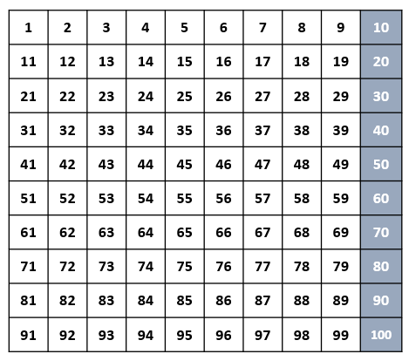

* Skip counting lays the foundation for mathematical content that students will learn in subsequent grades, such as:
  + skip counting forward by 2s, 5s, 10s, 25s, and 100s and skip counting backwards by 10s to compute numbers flexibly;
  + starting at 0 and skip counting by twos to determine even numbers;
  + starting at 0 and skip counting by fives to read time on a clock to the nearest five minutes or count the value of a collection of nickels;
  + starting at 0 and skip counting by tens to count the value of a collection of dimes or using base 10 blocks to determine place value;
  + starting at 0 and skip counting by twenty-fives to count the value of a collection of quarters; and
  + skip counting by hundreds and using base 10 blocks to determine place value.
* Calculators can be used to display the numerical increasing patterns resulting from skip counting. The constant feature of the four-function calculator can be used to display the numbers in the sequence when skip counting by that constant.
* Exploring ways to estimate the number of objects in a set, based on appearance (e.g., clustering, grouping, comparing), enhances the development of number sense.
* To estimate means to determine a number that is close to the exact amount. When asking for an estimate, teachers might ask, “*About* how much?” or “*About* how many?” or “Is this *about* 5, 50, or 500?”
* Opportunities to estimate a quantity, given a benchmark of 10 and/or 100 objects, enhance a student’s ability to estimate with greater accuracy.
* Odd and even numbers can be explored in different ways (e.g., dividing collections of objects into two equal groups or pairing objects in a group). When dividing a collection of objects into two equal groups, if there are no objects leftover, then the number is event. If an object is leftover, then the number is odd. When pairing objects, the number of objects is even when each object has a pair or partner. When an object is left over, or does not have a pair, then the number is odd.
* Examples of ways to use manipulatives to show even and odd numbers may include (but are not limited to):
  + for an even number, such as 12, six pairs of counters can be formed with no counters remaining, or two groups of six counters (two addends of 6) can be formed with no counters remaining. This can connect to fluency strategies for doubling; and
  + for an odd number, such as 13, six pairs of counters can be formed with one counter remaining, or two groups of six counters can be formed with one counter remaining (two addends of 6 plus 1 more). This can connect to fluency strategies for doubling +1.

###### Skills in Practice

While the five process goals are expected to be embedded in each standard, the Skills in Practice highlight the most prevalent process goals in relation to the content presented.

**Mathematical Problem Solving:** Students will develop their contextual and conceptual understanding as they solve problems involving skip counting, estimation, and even/odd numbers.

**Mathematical Communication:**

* Students may have difficulty counting objects that are in groups. For example, given the picture below, when asked to count by 2s to determine how many lollipops there are, a student may count each group of lollipops as one and arrive at the answer “six.”
* Students who are not able to count by twos may need practice with one-to-one counting to confirm that each set includes two items.
* Students may also benefit from practice counting by twos using a hundreds chart to build conceptual understanding.

Six pairs of two lollipops


**Mathematical Connections:**

* When students are skip counting by 5s, 10s, and 25s, they can make connections to counting money (nickels, dimes, and quarters).
* Counting by 2s, 5s, and 10s is a necessary skill when creating and/or analyzing bar graphs with scales of 2, 5, or 10 or pictographs with keys where each picture represents 2, 5, or 10 objects.

**Mathematical Representations:**

* Students should have exposure to and practice with estimating quantities, given benchmarks of 10 and/or 100 objects. This will help students learn to estimate with greater accuracy. For example, tell students that there are 10 grapes on the napkin and ask students to estimate how many grapes are in the bunch of grapes.

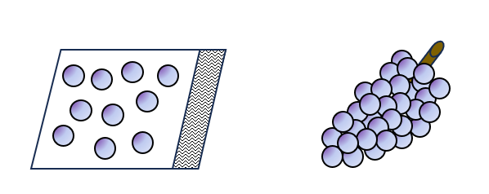

* Using concrete objects will assist students when justifying reasoning while clustering, grouping, and comparing numbers. Further, recognition of both forward and backward number patterns are enhanced by the use of concrete objects, number lines, and hundred charts.

###### Concepts and Connections

Concepts

Flexibility with composing and decomposing base 10 numbers and understanding the structure to build relationships among numbers allows us to quantify, measure, and make decisions in life.

Connections

* *Within the grade level/course*:
  + 2.NS.2 – The student will demonstrate an understanding of the ten-to-one relationships of the base 10 number system to represent, compare, and order whole numbers up to 999.
  + 2.NS.4 – The student will solve problems that involve counting and representing money amounts up to $2.00
* *Vertical Progression*:
  + K.NS.1 – The student will utilize flexible counting strategies to determine and describe quantities up to 100.
  + 1.NS.1 – The student will utilize flexible counting strategies to determine and describe quantities up to 120.
  + 3.NS.1 – The student will use place value understanding to read, write, and determine the place and value of each digit in a whole number, up to six digits, with and without models.
    - a) Read and write six-digit whole numbers in standard form, expanded form, and word form.
    - c) Compose, decompose, and represent numbers up to 9,999 in multiple ways, according to place value (e.g., 256 can be 1 hundred, 14 tens, 16 ones, but also 25 tens, 6 ones), with and without models.

Across Content Areas [Theme – Numbers, Number Sense, and Patterns]

* *Science:* 
  + 2.4 – The student will investigate and understand that plants and animals undergo a series of orderly changes as they grow and develop.
  + 2.6b – The student will observe, describe, and record daily weather conditions using weather instruments; graph and analyze data to identify patterns; and predict weather based upon identified patterns.
  + 2.6c – The student will observe and describe seasonal weather patterns and local variations.
  + 2.7 – The student will investigate and understand that weather patterns and seasonable changes affect plants, animals, and their surroundings.
* *Computer Science*:
  + 2.AP.1 – The student will apply computational thinking to identify patterns, and design algorithms to compare and contrast objects based on attributes.
    - a) Compare and contrast multiple ways to sort a set of objects.
    - b) Create a table of features to organize objects.
    - c) Design an algorithm to sort objects into categories based on multiple attributes.
  + 2.AP.2 – The student will identify a section of repeated actions within an algorithm and replace it with a loop.

###### Resources to Support Local Curriculum

* A list of approved textbooks and instructional materials is posted on the VDOE [website](https://www.doe.virginia.gov/teaching-learning-assessment/k-12-standards-instruction/mathematics/2024-mathematics-textbooks).
* Guess My Pattern Exemplar Mathematics Instructional Plan ([Word](https://www.doe.virginia.gov/home/showpublisheddocument/51733/638398745245270000) | [PDF](https://www.doe.virginia.gov/home/showpublisheddocument/51735/638398745251370000))
* Even or Odd Exemplar Mathematics Instructional Plan ([Word](https://www.doe.virginia.gov/home/showpublisheddocument/51737/638398745257130000) | [PDF](https://www.doe.virginia.gov/home/showpublisheddocument/51739/638398745263230000))

### 2.NS.2

##### The student will demonstrate an understanding of the ten-to-one relationships of the base 10 number system to represent, compare, and order whole numbers up to 999.

1. Students will demonstrate the following Knowledge and Skills:
2. Write the three-digit whole number represented by a given model (e.g., concrete objects, pictures of base 10 blocks).
3. Read, write, and represent three-digit numbers in standard form, expanded form, and word form, using concrete or pictorial representations.
4. Apply patterns within the base 10 system to determine and communicate, orally and in written form, the place (ones, tens, hundreds) and value of each digit in a three-digit whole number (e.g., in 352, the 5 represents 5 tens and its value is 50).
5. Investigate and explain the ten-to-one relationships among ones, tens, and hundreds, using models.
6. Compose and decompose whole numbers up to 200 by making connections between a variety of models (e.g., base 10 blocks, place value cards, presented orally, in expanded or standard form) and counting strategies (e.g., 156 can be 1 hundred, 5 tens, 6 ones; 1 hundred, 4 tens, 16 ones; 15 tens, 6 ones).
7. Plot and justify the position of a given number up to 100 on a number line with pre-marked benchmarks of 1s, 2s, 5s, 10s, or 25s.
8. Compare two whole numbers, each 999 or less, represented concretely, pictorially, or symbolically, using words (greater than, less than, or equal to) and symbols (>, <, or =). Justify reasoning orally, in writing, or with a model.
9. Order up to three whole numbers, each 999 or less, represented concretely, pictorially, or symbolically from least to greatest and greatest to least.

###### Understanding the Standard

* A strong place value foundation is important when representing, comparing, and ordering numbers. Hands-on experiences are essential to developing the ten-to-one place value understanding for the base 10 number system and when determining the value of each digit in a three-digit number.
* Models that accurately illustrate the relationships among ones, tens, and hundreds, are physically proportional (e.g., the tens piece is ten times larger than the ones piece).
* Manipulatives that can be physically connected and separated into groups of hundreds, tens, and leftover ones (e.g., snap cubes, beans on craft sticks, pennies in cups, bundles of sticks, beads on pipe cleaners) should be used prior to transitioning to base 10 blocks, which cannot be broken apart.
* Ten-to-one trading activities with manipulatives on place value mats provide experiences for developing the understanding of the places in the base 10 system. Place value cards that show numbers in expanded form can help students conceptualize the value of each place as they use models to build and represent numbers.
* Flexibility in thinking about numbers is critical (e.g., 84 is equivalent to 8 tens and 4 ones, or 7 tens and 14 ones, or 84 ones). This flexibility builds background knowledge for the concepts used when regrouping. For example, when subtracting 18 from 184, a student may choose to regroup and think of 184 as 1 hundred, 7 tens, and 14 ones. Students would benefit from experiences building multiple representations of two-digit numbers before progressing to three-digit numbers.
* Number lines with pre-marked benchmarks of 1s, 2s, 5s, 10s, or 25s are useful tools for developing an understanding of place value (see examples below). They can be used to plot and justify the position of a given number up to 100, and to make connections to rounding when estimating.

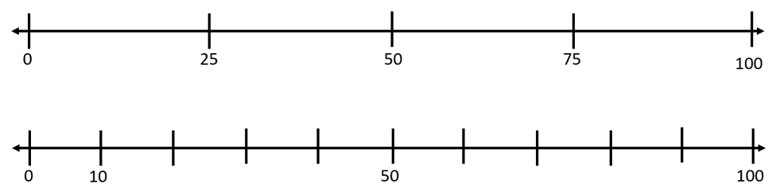

###### Skills in Practice

While the five process goals are expected to be embedded in each standard, the Skills in Practice highlight the most prevalent process goals in relation to the content presented.

**Mathematical Problem Solving:** Students should solve a variety of problems involving three-digit numbers, including those that use authentic data. Prior to solving problems, students should be encouraged to estimate the solution. More information about problem solving is found in the Skills in Practice section for 2.CE.1.

**Mathematical Reasoning:**

* Students may not understand that different places have different values. For example, given the number 162, they may not understand that the 1 has the greatest value. Instead, they may think the 6 has the greatest value because it is the “most” or the “biggest.” The use of concrete proportional manipulatives such as base 10 blocks may help students develop this understanding, as they can observe that one hundred is greater than six tens.
* When comparing numbers, students may incorrectly start by comparing the ones place. For example, if given the numbers 258 and 514, they may say that 258 is greater because it has 8 ones and 514 only has 4 ones. The use of concrete proportional manipulatives such as base 10 blocks may help students develop this understanding of comparing numbers starting in the greatest place value.

**Mathematical Representations:**

* Students may have difficulty representing three-digit numbers, especially those that include zeros. For example, given the number *two hundred five*, students may write “25” and read the number as “twenty-five.” Neglecting to include a zero in the number may indicate that students do not understand that all place values must be represented when writing and reading a number. Another common error a student may make is to state that the model below represents the number “250” and read the number as “two hundred fifty.” This indicates that the student understands that there must be a 0 in the number but are confused as to where the 0 is supposed to go. The use of a place value chart may be helpful to help students read, write, and represent three-digit numbers.

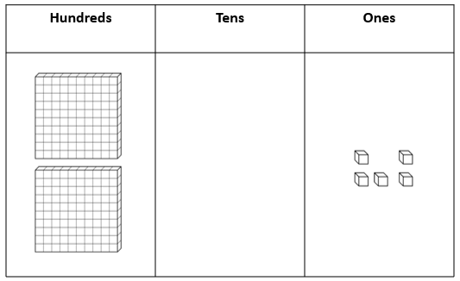

* Students may have difficulty representing numbers when the number or representation provided is not in the standard place value order. For example, if given the expanded form of a number as 60 + 7 + 300, students may write the standard form as 673. Similarly, given the representation below, students may incorrectly write that this number represents 52, 502, or 25. These errors may indicate a lack of understanding of the values associated with the base-10 manipulatives or difficulty translating from a model or expanded form to standard form, especially when one of the place value positions is not included in the model (e.g., there are no tens in the model below). Opportunities for students to translate concrete models to pictorial representations and the use of a place value chart to organize the values may support student understanding.

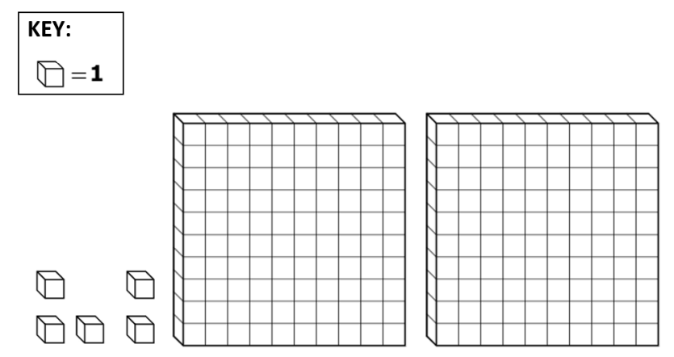

* Students may have difficulty representing numbers in multiple ways. For example, given the number 34, a student may not recognize that 34 can be represented as 3 tens and 4 ones and can also be represented as 2 tens and 14 ones or as 34 ones. (See the example below.) Students who make this error would benefit from additional experiences with trading activities using base 10 blocks or other manipulatives that provide opportunities to represent the same number in more than one way. Students may also benefit from beginning with smaller two-digit numbers and then progressing to larger two-digit numbers.

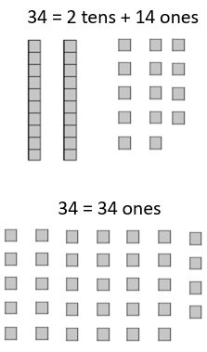

###### Concepts and Connections

Concepts

Flexibility with composing and decomposing base 10 numbers and understanding the structure to build relationships among numbers allows us to quantify, measure and make decisions in life.

Connections

* *Within the grade level/course*:
  + 2.NS.1 – The student will utilize flexible counting strategies to determine and describe quantities up to 200.
* *Vertical Progression*:
  + 1.NS.2 – The students will represent, compare, and order quantities up to 120.
  + 3.NS.1 – The student will use place value understanding to read, write, and determine the place and value of each digit in a whole number, up to six digits, with and without models.
  + 3.NS.2 – The student will demonstrate an understanding of the base 10 system to compare and order whole numbers up to 9,999.

Across Content Areas

Reference 2.NS.1

###### Resources to Support Local Curriculum

* A list of approved textbooks and instructional materials is posted on the VDOE [website](https://www.doe.virginia.gov/teaching-learning-assessment/k-12-standards-instruction/mathematics/2024-mathematics-textbooks).
* Place Value Mat Activities Exemplar Mathematics Instructional Plan ([Word](https://www.doe.virginia.gov/home/showpublisheddocument/51741/638398745268070000) | [PDF](https://www.doe.virginia.gov/home/showpublisheddocument/51743/638398745273870000))

### 2.NS.3

##### The student will use mathematical reasoning and justification to solve contextual problems that involve partitioning models into equal-sized parts (halves, fourths, eighths, thirds, and sixths).

1. Students will demonstrate the following Knowledge and Skills:
2. Model and describe fractions as representing equal-size parts of a whole.
3. Describe the relationship between the number of fractional parts needed to make a whole and the size of the parts (i.e., as the whole is divided into more parts, each part becomes smaller).
4. Compose the whole for a given fractional part and its value (in context) for halves, fourths, eighths, thirds, and sixths (e.g., when given , determine how many pieces would be needed to make ).
5. Using same-size fraction pieces, from a region/area model, count by unit fractions up to two wholes (e.g., zero one-fourths, one one-fourth, two one-fourths, three one-fourths, four one-fourths, five one-fourths; or zero-fourths, one-fourth, two-fourths, three-fourths, four-fourths, five-fourths).
6. Given a context, represent, name, and write fractional parts of a whole for halves, fourths, eighths, thirds, and sixths using:
   1. region/area models (e.g., pie pieces, pattern blocks, geoboards);
   2. length models (e.g., paper fraction strips, fraction bars, rods, number lines); and
   3. set models (e.g., chips, counters, cubes).
7. Compare unit fractions for halves, fourths, eighths, thirds, and sixths using words (greater than, less than or equal to) and symbols (>, <, =), with region/area and length models.

###### Understanding the Standard

* Understanding fractions means understanding all the possible concepts that fractions can represent. Students must experience fractions across many constructs, including part of a whole, ratios, and division. At this grade level, students will use a fraction as a numerical way of representing part of a whole region (e.g., an area model), part of a group (e.g., a set model), or part of a length (e.g., a measurement model). At this level, models should be used extensively to support student understanding of the different fraction concepts.
* Fractional parts are equal shares or equal-sized portions of a whole or unit. A unit can be an object or a collection of things. Fair sharing problems (i.e., equal shares) is an idea that young children understand intuitively because of experiences sharing objects with siblings, friends, etc.
* When working with fractions, the whole must be defined. A whole can be partitioned in multiple ways so that the parts are equivalent. At this level, students may have difficulty drawing figures or partitioning figures accurately.
* Fractional parts have special names that tell how many parts of that size are needed to make the whole. For example, thirds require three equal parts to make a whole.
* A unit fraction is a fraction whose numerator is 1 (e.g., , ).
* The more fractional parts needed to make a whole, the smaller the parts will be. For example, eighths are smaller than fourths. Students should have experiences dividing a whole into additional parts. As the whole is divided into more parts, students should begin to make conjectures that each part becomes smaller (e.g., folding a paper in half one time, creates two halves; folding it in half again, creates four fourths, which are smaller pieces; folding it in half again, creates eight eighths, which are even smaller pieces).
* Fraction notation is introduced in Grade 2. As students use models to investigate fractions, teachers should introduce the convention for writing a fraction using the symbolic notation such as . In this notation 4, the denominator, represents the number of equal-sized parts needed to make a whole and 3, the numerator, represents the number of parts under consideration in the whole. The part of the whole under consideration may be the shaded or the unshaded part of a picture.
* Language such as “out of” (e.g., is the same as 3 out of 4) can lead to misconceptions and partial understandings in naming the numerator and denominator as whole numbers. Instead, the use of accurate fraction vocabulary (e.g., three one-fourths or three-fourths) builds understanding of magnitude of fractional size and value.
* Students at this level may try to inaccurately apply whole number reasoning in their work with fractions before they gain a deep understanding of fractions as numbers. For example, they may say that is less than than because 2 is less than 4. Solving contextual problems working with models and explaining how the model represents the fraction will strengthen students’ understanding.
* Opportunities to compose fractions and make connections among fraction representations by connecting concrete or pictorial representations with spoken or symbolic representations will deepen fraction sense.
* When given a fractional part of a whole and its value (e.g., one-third), students should explore with models how many fractional parts it will take to build one whole, to build two wholes, etc.

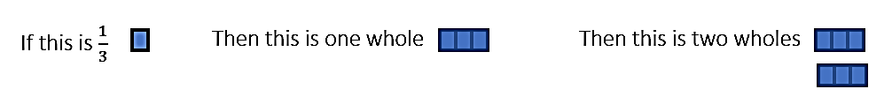

* Counting unit fractional parts to build the whole will support student understanding of how many parts are needed to make a whole (e.g., that four-fourths make one whole). It is important that students count fractional parts both by naming the unit fraction with each count (e.g., ONE one-fourth, TWO one-fourths…) and counting consecutive parts (e.g., one-fourth, two-fourths…) to build their sense of fraction magnitude.

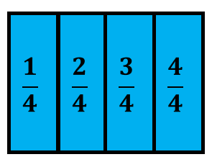

* Students should be provided opportunities to use models to count fractional parts that go beyond one whole. As a result of building the whole while they are counting, students will begin to generalize that when the numerator and the denominator are the same, there is one whole and when the numerator is larger than the denominator, there is more than one whole. They also will begin to see a fraction as the sum of unit fractions (e.g., three-fourths is the same as three one-fourths or six-sixths is the same as six one-sixths, which is equal to one whole). This provides students with a visual for when one whole is reached and helps students develop a greater understanding of the relationship between the numerator and denominator.

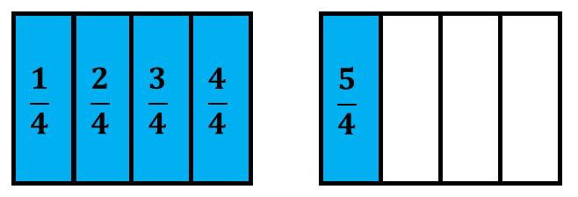

* In a region/area model, the whole is a continuous region and can be partitioned/divided into parts having the same area. Region/area models (e.g., circular and rectangular pie pieces, pattern blocks, geoboards, folding paper) are helpful tools for students. As they touch and move the concrete objects, students begin to understand the part-to-whole relationship and other concepts about fractions.

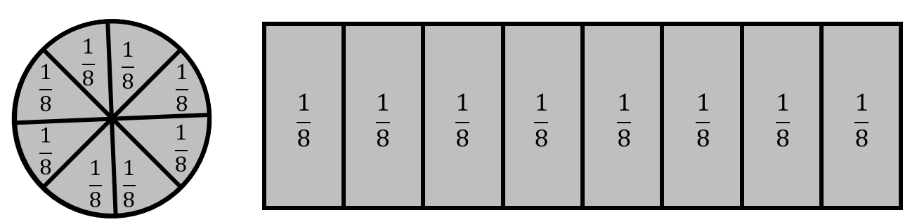

* In a length model, the whole is continuous, and each partitioned length represents an equal part of the whole length. For example, given a strip of paper, students could fold the strip into four equal parts, with each part representing one-fourth. Students will notice the length of the first section has length , the next section is two s, etc. Students should connect a concrete model to a representation of a number line to make sense of the spaces that show the value of the fraction.

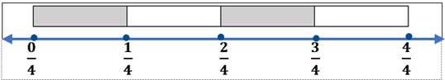

* In a set model, the whole is discontinuous, and the set of discrete items represents the whole. Each item in the set represents an equivalent part of the set. For example, in a set of six counters, one counter represents one-sixth of the set. In the set model, the set can be subdivided into subsets with the same number of items in each subset. For example, a set of six counters can be subdivided into two subsets of three counters each and each subset represents three-sixths or one-half of the whole set.

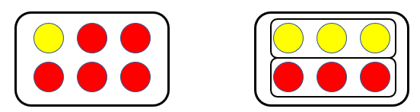

* Using models when comparing unit fractions supports the understanding that as the number of pieces needed to make a whole increases, the size of each individual piece decreases (i.e., the larger the denominator, the smaller the piece when the pieces are from the same size whole; therefore, > ). Students in Grade 2 will only compare unit fractions using area/region and length models.

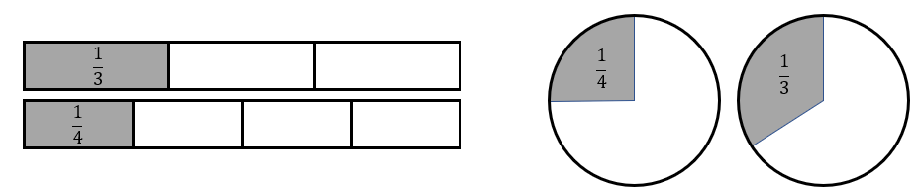

* Students in Grade 2 are not expected to convert a fraction greater than one into a mixed number or vice versa. Students will formally learn to represent fractions greater than one as well as mixed numbers symbolically in Grade 3.

###### Skills in Practice

While the five process goals are expected to be embedded in each standard, the Skills in Practice highlight the most prevalent process goals in relation to the content presented.

**Mathematical Reasoning:** Students may have misconceptions about comparing fractions. Students will often use whole number reasoning when comparing fractions. For example, they may say that is less than because 3 is less than 4. Students who make this mistake would benefit from additional practice of dividing a whole into parts and naming the parts after each division is made. These experiences help students conceptualize that as the whole is divided into more parts, each part becomes smaller.

**Mathematical Connections:** Students may have difficulty understanding what the numerator and denominator represent, and the connection between the numerator and denominator. A common error is for students to identify the numerator as “the number of pieces that are being considered,” and the denominator as “the number of pieces that are not being considered.” For example, given the image below, they may incorrectly determine that the shaded part represents or because there are three parts shaded, and one part not shaded. Students who make this mistake do not recognize the part-whole relationship represented by fraction notation and would benefit from explicit instruction in and practice with the naming conventions for fractions.

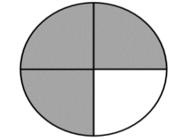

**Mathematical Representations:** Students may have difficulty identifying fractions on a number line. A common error is for students to count the number of tick marks instead of the number of equal spaces between whole numbers. For example, given the image below, they may indicate that the fraction represented by the arrow is . This error may indicate a misconception that the denominator for a fraction modeled on a number line represents the number of tick marks on the number line instead of the number of equal spaces between whole numbers. Students who make this mistake may benefit from creating number lines and gluing same-size strips of alternating colors of paper end-to-end to create physical models of number lines. This will help build understanding of the number line model of fractions and what is being counted.

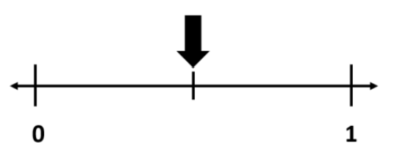

###### Concepts and Connections

Concepts

Flexibility with composing and decomposing base 10 numbers and understanding the structure to build relationships among numbers allows us to quantify, measure and make decisions in life.

Connections

* *Within the grade level/course*:
  + 2.MG.1 – The student will reason mathematically using standard units (U.S. Customary) with appropriate tools to estimate, measure, and compare objects by length, weight, and liquid volume to the nearest whole unit.
* *Vertical Progression*:
  + 1.NS.3 – The student will use mathematical reasoning and justification to solve contextual problems that involve partitioning models into two and four equal-sized parts.
  + 3.NS.3 – The student will use mathematical reasoning and justification to represent and compare fractions (proper and improper) and mixed numbers with denominators of 2, 3, 4, 5, 6, 8, and 10, including those in context.

Across Content Areas

Reference 2.NS.1

###### Resources to Support Local Curriculum

* A list of approved textbooks and instructional materials is posted on the VDOE [website](https://www.doe.virginia.gov/teaching-learning-assessment/k-12-standards-instruction/mathematics/2024-mathematics-textbooks).

### 2.NS.4

##### The student will solve problems that involve counting and representing money amounts up to $2.00.

1. Students will demonstrate the following Knowledge and Skills:
2. Identify a quarter and its value and determine multiple ways to represent the value of a quarter using pennies, nickels, and/or dimes.
3. Count by ones, fives, tens, and twenty-fives to determine the value of a collection of mixed coins and one-dollar bills whose total value is $2.00 or less.
4. Construct a set of coins and/or bills to total a given amount of money whose value is $2.00 or less.
5. Represent the value of a collection of coins and one-dollar bills (limited to $2.00 or less) using the cent (¢) and dollar ($) symbols and decimal point (.).

###### Understanding the Standard

* The money system used in the United States consists of coins and bills based on relationships involving ones, fives, and tens. The dollar is the basic unit. Experiences with real currency will allow for exposure to various representations of each coin (e.g., state quarters, newer currency compared to older currency).
* The value of a collection of coins and bills can be determined by beginning with the highest value, and/or by grouping the coins and bills into groups and skip counting or counting on to determine the value.
* Students need opportunities to construct and count collections of coins and one-dollar bills whose total value is $2.00 or less, including trading and grouping a variety of coin combinations.
* Emphasis is placed on the representation of the symbols for dollars and cents (e.g., $0.35 and 35¢ are both read as “thirty-five cents”; $2.00 is read as “two dollars”).
* Students at this level have not formally been introduced to the meaning of the decimal point; however, when reading money amounts, they should represent the amount orally by stating “and” when they reach the decimal point. For example, $1.15 should be read as “one dollar and 15 cents.” Decimals are formally introduced in Grade 4.

###### Skills in Practice

While the five process goals are expected to be embedded in each standard, the Skills in Practice highlight the most prevalent process goals in relation to the content presented.

**Mathematical Problem Solving:** Students may have difficulty solving problems that require counting collections that cross over $1.00. For example, if they have $0.95 and add a dime, they may incorrectly state the total as $1.00 instead of $1.05. Students would benefit from using money manipulatives and having opportunities to represent a given money amount in more than one way. Activities where students are collaborating with peers to compare different ways to represent a given value may be beneficial and will promote mathematical discourse in the classroom.

**Mathematical Representations:** Students may have difficulty writing the value of a collection of money if the value includes a zero. For example, if the value of a collection is $1.07, students may incorrectly write it as $1.7 or $1.70 or $17 or $0.17. This may indicate that students do not have a strong understanding of the notation used to represent dollars and cents. Additional experiences sharing different representations for given values may be helpful for these students.

###### Concepts and Connections

Concepts

Flexibility with composing and decomposing base 10 numbers and understanding the structure to build relationships among numbers allows us to quantify, measure and make decisions in life.

Connections

* *Within the grade level/course*:
  + 2.NS.1 – The student will utilize flexible counting strategies to determine and describe quantities up to 200.
* *Vertical Progression*:
  + 1.NS.1- The student will utilize flexible counting strategies to determine and describe quantities up to 120.
    - f) Identify a penny, nickel, and dime by their attributes and describe the number of pennies equivalent to a nickel and a dime.
    - g) Count by ones, fives, or tens to determine the value of a collection of like coins (pennies, nickels, or dimes), whose total value is 100 cents or less.
  + 3.NS.4 – The student will solve problems, including those in context, that involve counting, comparing, representing, and making change for money amounts up to $5.00.

Across Content Areas

Reference 2.NS.1.

###### Resources to Support Local Curriculum

* A list of approved textbooks and instructional materials is posted on the VDOE [website](https://www.doe.virginia.gov/teaching-learning-assessment/k-12-standards-instruction/mathematics/2024-mathematics-textbooks).
* Race to a Dollar or Two! Exemplar Mathematics Instructional Plan ([Word](https://www.doe.virginia.gov/home/showpublisheddocument/51745/638398745279170000) | [PDF](https://www.doe.virginia.gov/home/showpublisheddocument/51747/638398745284970000))

## Computation and Estimation

In K-12 mathematics, computation and estimation are integral to developing mathematical proficiency. Computation refers to the process of performing numerical operations, such as addition, subtraction, multiplication, and division. It involves applying strategies and algorithms to solve arithmetic problems accurately and efficiently. Estimation is the process of obtaining a reasonable or close approximation of a result without performing an exact calculation. Estimation is particularly useful when an exact answer is not required, especially in real-world situations, and when assessing the reasonableness of an answer. Computation and estimation are used to support problem solving, critical thinking, and mathematical reasoning by providing students with a range of approaches to solve mathematics problems quickly and accurately.

In Grade 2, students will use the operations of addition and subtraction to represent and solve many different types of problems. Students at this grade level will recall with automaticity addition and subtraction facts within 20; and will estimate, represent, solve, and justify solutions to single-step and multistep addition and subtraction problems where addends and minuends do not exceed 100. For building automaticity, the intentional use of timed exercises such as flashcards and/or supplemental handouts aligned to the rigor of the standard that require students to generate many correct responses in a short amount of time are highly encouraged.

It is critical at this grade level that while students build their conceptual understanding through concrete and pictorial representations, that students also apply standard algorithms when performing operations as specified within the parameters of each standard of this strand. At this grade level, students become more efficient with problem solving strategies. Fluent use of standard algorithms not only depends on automatic retrieval (automaticity) but also reinforces them. Practice provides the foundation allowing students the ability to achieve mathematically accurate and systematic use of basic skills at a reasonably quick pace – freeing up working memory to solve complex problems in later grades. Automaticity further grounds students’ entry points and the structures needed to solve contextual problems and execute mathematical procedures.

### 2.CE.1

##### The student will recall with automaticity addition and subtraction facts within 20 and estimate, represent, solve, and justify solutions to single-step and multistep problems, including those in context, using addition and subtraction with whole numbers where addends or minuends do not exceed 100.

1. Students will demonstrate the following Knowledge and Skills:
2. Apply strategies (e.g., rounding to the nearest 10, compatible numbers, other number relationships) to estimate a solution for single-step addition or subtraction problems, including those in context, where addends and minuends do not exceed 100.
3. Apply strategies (e.g., the use of concrete and pictorial models, place value, properties of addition, the relationship between addition and subtraction) to determine the sum or difference of two whole numbers where addends or minuends do not exceed 100.
4. Represent, solve, and justify solutions to single-step and multistep contextual problems (e.g., join, separate, part-part-whole, comparison) involving addition or subtraction of whole numbers where addends or minuends do not exceed 100.
5. Demonstrate fluency with addition and subtraction within 20 by applying reasoning strategies (e.g., doubles, near doubles, make-a-ten, compensations, inverse relationships).
6. Recall with automaticity addition and subtraction facts within 20.
7. Use patterns, models, and strategies to make generalizations about the algebraic properties for fluency (e.g., 4 + 3 is equal to 3 + 4; 0 + 8 = 8).
8. Determine the missing number in an equation (number sentence) through modeling and justification with addition and subtraction within 20 (e.g., 3 + = 5 or + 2 = 5; 5 – = 3 or 5 – 2 = ).
9. Use inverse relationships to write all related facts connected to a given addition or subtraction fact model within 20 (e.g., given a model for 3 + 4 = 7, write 4 + 3 = 7, 7 – 4 = 3, and 7 – 3 = 4).
10. Describe the not equal symbol (≠) as representing a relationship where expressions on either side of the not equal symbol represent different values and justify reasoning.
11. Represent and justify the relationship between values and expressions as equal or not equal using appropriate models and/or symbols (e.g., 9 + 24 = 10 + 23; 45 - 9 = 46 - 10; 15 +16 ≠ 31 +15).

###### Understanding the Standard

* Estimation is a valuable, time-saving skill used when exact answers are not required or needed, especially in practical situations.
* Estimation can be used to check the reasonableness of the sum or difference when an exact answer is required.
* Rounding is one strategy used to estimate. It is often used to assess the reasonableness of a solution or to give an estimate of an amount. Rounding a number to the nearest ten means determining which two tens the number lies between and then determining which ten the number is closest to (e.g., 48 is between 40 and 50 and rounded to the nearest ten is 50, because 48 is closer to 50 than it is to 40).
* Using compatible numbers is another estimation strategy. Compatible numbers are two or more numbers that are easy to add and subtract mentally. For example, using compatible numbers to estimate the sum of 57 + 45 could result in 60 + 40 = 100.
* Mental computation helps build students’ number sense. Mentally adding or subtracting two-digit numbers may include strategies such as those shown below:

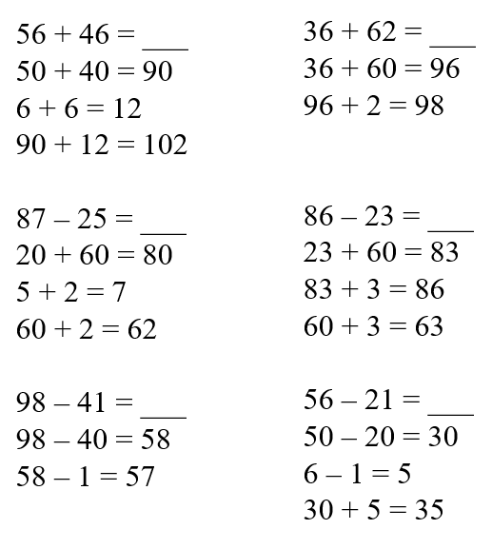

* The terms utilized in addition and subtraction include:

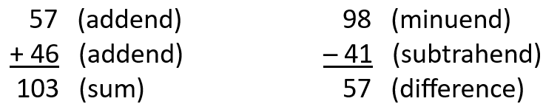

* At this level, students do not need to use the terms *addend, minuend,* or *subtrahend* for addition and subtraction.
* Addition and subtraction should be taught concurrently to develop an understanding of inverse relationships.
* Addition and subtraction problems should be presented in both horizontal and vertical written formats.
* Conceptual understanding and computational fluency are built by using various strategies and representations. Regrouping is used in addition and subtraction algorithms and can be challenging for many students to understand. The use of concrete materials (e.g., base 10 blocks, connecting cubes, beans and cups) to explore, model, and stimulate discussion about a variety of problem situations helps students understand the concept of regrouping, and enables them to move forward from the concrete to the representational to the abstract (symbolic). Student-created representations, such as drawings, diagrams, tally marks, graphs, or written comments are strategies that students use as they make these connections that lead to developing computational fluency.
* Problem-solving means engaging in a task for which a solution or a method of solution is not known in advance. Solving problems using data and graphs offers one way to connect mathematics to practical situations.
* In problem-solving, emphasis should be placed on thinking and reasoning rather than on key words. Focusing on key words such as *in all, altogether, difference,* etc.,encourages students to perform a particular operation rather than make sense of the context of the problem. A key word focus prepares students to solve a limited set of problems and often leads to incorrect solutions as well as challenges in upcoming grades and courses.
* Extensive research has been undertaken over the last several decades regarding different problem types. Many of these studies have been published in professional mathematics education publications using different labels and terminology to describe the varied problem types.
* Students should experience a variety of problem types related to addition and subtraction. Problem type examples are included in the following chart:

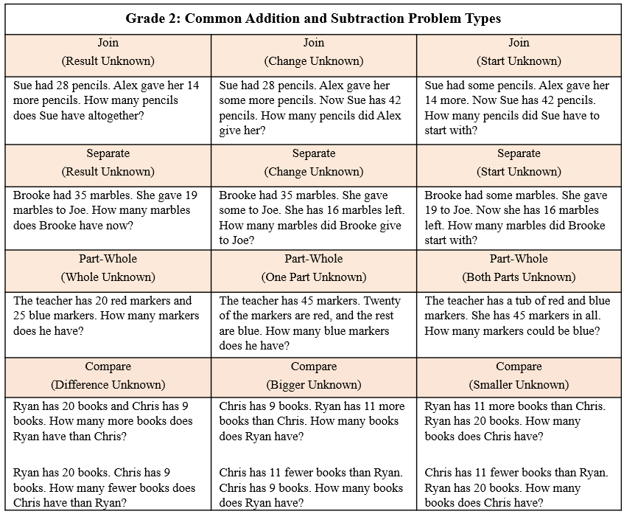

* The problem-solving process is enhanced when students:
  + visualize the action in the story problem and draw a picture to show their thinking;
  + model the problem using manipulatives, representations, and/or number sentences/equations; and
  + justify their reasoning and varied approaches through collaborative discussions.
* Computational fluency is the ability to think flexibly in order to choose appropriate strategies to solve problems accurately and efficiently. Students should develop fluency and recall with automaticity facts to 20.
* Flexibility requires knowledge of more than one approach to solving a particular kind of problem. Being flexible allows students to choose an appropriate strategy for the numbers involved, particularly where they do not need to recall with automaticity.
* Meaningful practice of computation strategies can be attained through hands-on activities, manipulatives, and graphic organizers.
* Accuracy is the ability to determine a correct answer using knowledge of number facts and other important number relationships.
* Efficiency is the ability to carry out a strategy effortlessly at a reasonably quick pace.
* Concrete models should be used initially to develop an understanding of addition and subtraction facts.
* Automaticity of facts can be achieved through timed exercises such as flashcards and/or supplemental handouts to generate many correct responses in a short amount of time.
* The following chart includes examples of common addition and subtraction strategies:

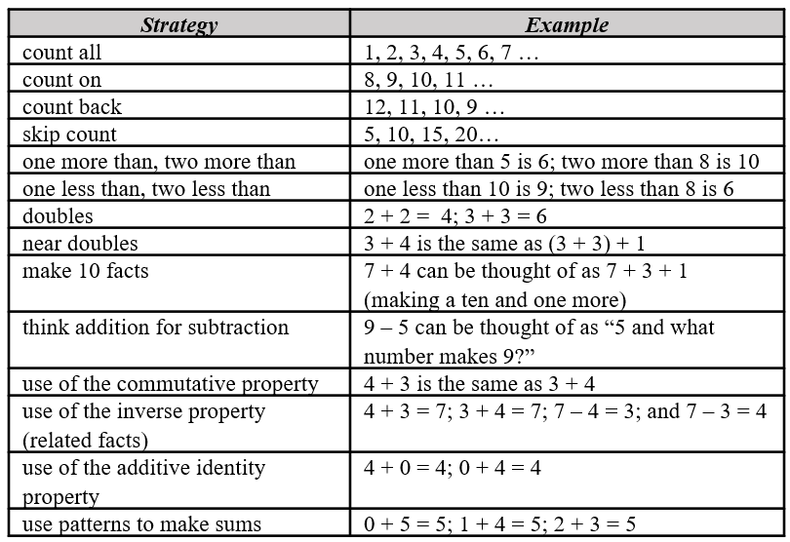

* The understanding of related facts can be applied when finding the solution to problems involving a missing addend in addition sentences or missing parts in subtraction sentences. This understanding is developed through experiences with inverse relationships and is used as a strategy to develop fluency.
* Grade 2 students should begin to explore and generalize the properties of addition as strategies for solving addition and subtraction problems using a variety of representations.
* The properties of the operations are “rules” about how numbers work and how they relate to one another. Students at this level do not need to use the formal terms for these properties but should utilize these properties to further develop flexibility and fluency in solving problems. The following properties are most appropriate for exploration at this level:
  + the commutative property of addition states that changing the order of the addends does not affect the sum (e.g., 4 + 3 = 3 + 4);
  + the identity property of addition states that if zero is added to a given number, the sum is the same as the given number (e.g., 0 + 2 = 2); and
  + the associative property of addition states that the sum stays the same when the grouping of addends is changed (e.g., 4 + (6 + 7) = (4 + 6) + 7).
* Models such as 10 or 20 frames and part-part-whole diagrams help develop an understanding of relationships between equations and operations.
* Manipulatives such as connecting cubes, counters, and number scales can be used to model equations.

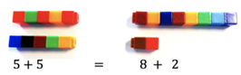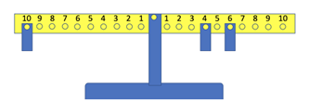

* The equal sign (=) is a symbol used to indicate equivalence or balance. It represents a relationship where expressions on each side of the equal symbol represent the same value.
* The not equal sign (≠) is a symbol used to indicate nonequivalence. It represents a relationship where expressions on each side of the equal symbol represent different values.
* An equation (number sentence) is a mathematical statement representing two expressions that are equivalent. It consists of two expressions, one on each side of an equal sign (e.g., 5 + 3 = 8, 8 = 5 + 3, 4 + 3 = 9 - 2). An equation can be represented using a number balance scale, with equal amounts on each side (e.g., 3 + 5 = 6 + 2). A balance scale should be used to develop the ideas of equivalence and nonequivalence concretely.
* An expression represents a quantity. An expression may contain numbers, variables, and/or computational operation symbols. It does not have an equal symbol (e.g., 5, 4 + 3, 8 - 2). Students at this level are not expected to use the terms *expression* or *variable*.
* Exploring equations in less familiar forms can help students build a deeper understanding of the concept of equality (e.g., 8 = 10 - 2, 5 = 5, or 7 ≠ 10 - 5). For students to develop the concept of equality, students need to see the = symbol used in various appropriate locations (e.g., 3 + 4 = 7, 5 = 2 + 3).

###### Skills in Practice

While the five process goals are expected to be embedded in each standard, the Skills in Practice highlight the most prevalent process goals in relation to the content presented.

**Mathematical Problem Solving:**

As students are exposed to different problem types (see table of problem types in the Understanding the Standard section), they have difficulty determining what operation to use to solve the problem. A common student error is to pull the numbers out of the context and add them. Instead, students need to make sense of the problem by first determining the action taking place. Opportunities to physically act out problems or to model problems with objects in order to visualize the action occurring in the problem will help students make sense of problems.

* Automatic retrieval of facts (automaticity) allows students more mental energy to devote to relatively complex mathematical tasks and execute multistep mathematical procedures. Thus, building automatic fact retrieval in students is one (of many) important goal when engaging in problem solving.
  + Ensure that students have an efficient strategy to use to solve basic facts. When teaching basic facts, instruction should be organized related to number combinations (see the “Examples of Addition and Subtraction Strategies” table in the Understanding the Standard section). For example, when solving single-step addition and subtraction problems within 20, students should use flexible counting strategies and/or models (e.g., number bonds, ten frames) to develop their automaticity while also developing their understanding of composition and decomposition of numbers. Students should demonstrate their understanding using words, objects, drawings, and numbers. For example, when given 12 + ___ = 20 (or the related fact of 20 – 12 = ___ ), students can create a concrete model or pictorial representation. A number bond (see below) is one strategy that can be used to support students’ learning of math facts to build both automaticity and procedural fluency.

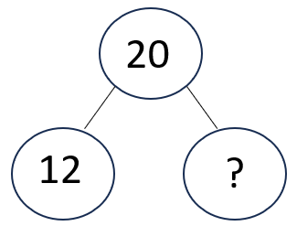

* Timed activities should be added once students have been working on developing accuracy and flexibility with such facts over many lessons. Choose the activity and materials to use in the timed activity while setting clear expectations. Timed activities can be structured for students to work together as a group or individually. If using worksheets for fluency, discuss students’ answers after time has been called and ask students to correct and explain any missed items. For group timed activities, students can work in pairs or small groups, taking turns to respond or responding all at once. For group activities or flash cards with a teacher, teachers should provide immediate feedback. If students are incorrect, teachers should allow students to self-correct and help them do so if necessary. Having students chart their individual progress over time can build motivation to set goals and encourage students to stay focused on achieving fluency and automaticity.

**Mathematical Communication:** It is important to teach students a solution method for solving each problem type. Introduce a solution method using a worked-out example. Talk through the problem-solving process and connect the relevant problem information to the worked-out example. Say out loud the decisions that were made to solve the problem at each step. Then demonstrate how to apply the solution method by solving a similar problem with students using that method. Discuss each decision made and ask students guiding questions to engage them as problems are solved.

**Mathematical Reasoning:**

* Students should apply a variety of reasoning strategies as they build the accuracy and flexibility components of fluency with addition and subtraction within 20 (e.g., counting on, use of number lines, doubles). However, students may demonstrate several common misconceptions. Students may use strategies incorrectly or may make a computation error when solving. For example, given the problem 12 – 3, students might recognize that 13 – 3 is a close fact, but then they may incorrectly adjust the 10 (from 13 – 3 = 10) by adding 1 instead of subtracting 1 to compensate for the difference between 13 and 12. It may be beneficial to introduce students to more efficient strategies, which will enhance students’ abilities to flexibly compose/decompose numbers to 20.
* Basic fact strategies use number relationships and benchmarks and support students, merging conceptual understanding and procedural fluency. Strategies such as “doubles plus one” build a foundation for strategies beyond basic facts. For example –

**7 + 8 = _____**

When looking at this problem, students need to combine the 7 and the 8. Counters may be used to count out a group of 7 and another group of 8, combine them, and count how many counters are there in all. For example, students may recognize that 7 + 7 is a double fact that equals 14, and solving 7 + 8 is adding one more to the 14 for a sum of 15. To transfer from the concrete, students would draw 7 circles to represent the 7 and 8 circles to represent the 8, and the count how many circles are drawn in all.

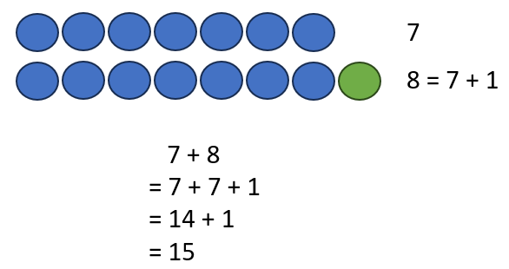

* Students may have difficulty determining whether two expressions are equal or not equal. For example, given the equation 8 – 2 = 6 + 4, students may state that 8 – 2 is equal to 6 + 4 because they are only considering the first number after the equal symbol and know that 8 – 2 = 6. Students who make this type of error would benefit from additional opportunities to use concrete manipulatives (e.g., base 10 blocks or cubes on a balance scale) to physically model each side of the equation.

**Mathematical Connections:** When writing a set of related facts, students commonly struggle with writing the subtraction facts accurately. For example, given the fact 7 + 6 = 13, students may incorrectly write 7 – 6 = 13 as a related subtraction fact. Students are often more comfortable with addition than subtraction. With practice composing, decomposing, modeling, looking at relationships among fact families, and having students provide verbal explanations, students can better understand how addition and subtraction are related, helping to develop the accuracy and flexibility components of computational fluency.

**Mathematical Representations:** Subtraction using the standard algorithm, especially when it requires regrouping, can be very difficult for Grade 2 students. There are several common misconceptions or errors that arise when students begin to solve problems with regrouping. For example, when solving a problem like 82 – 45, students may:

* recognize that they are unable to take 5 away from 2 and may switch the digits and take 2 away from 5, resulting in a difference of 43.
* recognize that they need to regroup but change the 2 into 10 (instead of 12), resulting in a difference of 35.
* recognize that they need to regroup, and change the 2 into a 12, but keep the 8 as is (instead of changing it to a 7), resulting in a difference of 47.

###### Concepts and Connections

Concepts

The operations of addition and subtraction are used to represent and solve many different types of problems.

Connections

* *Within the grade level/course*:
  + 2.PS.1e) Analyze data represented in pictographs and bar graphs and communicate results:
    - i) ask and answer questions about the data represented in pictographs and bar graphs (e.g., total number of data points represented, how many in each category, how many more or less are in one category than another). Pictograph keys will be limited to symbols representing 1, 2, 5, or 10 pieces of data and bar graphs will be limited to scales with increments in multiples of 1, 2, 5, or 10
  + 2.PFA.1 – The student will describe, extend, create, and transfer repeating and increasing patterns (limited to addition of whole numbers) using various representations.
* *Vertical Progression*:
  + 1.CE.1 – The student will recall with automaticity addition and subtraction facts within 10 and represent, solve, and justify solutions to single-step problems, including those in context, using addition and subtraction with whole numbers within 20.
  + 3.CE.1 – The student will estimate, represent, solve, and justify solutions to single-step and multistep problems, including those in context, using addition and subtraction with whole numbers where addends and minuends do not exceed 1,000.

###### Resources to Support Local Curriculum

* A list of approved textbooks and instructional materials is posted on the VDOE [website](https://www.doe.virginia.gov/teaching-learning-assessment/k-12-standards-instruction/mathematics/2024-mathematics-textbooks).
* Four-in-a-Row Computation Exemplar Mathematics Instructional Plan ([Word](https://www.doe.virginia.gov/home/showpublisheddocument/51729/638398745233070000) | [PDF](https://www.doe.virginia.gov/home/showpublisheddocument/51731/638398745239170000))

## Measurement and Geometry

In K-12 mathematics, measurement and geometry allow students to gain understanding of the attributes of shapes as well as develop an understanding of standard units of measurement. Measurement and geometry are imperative as students develop a spatial understanding of the world around them. The standards in the measurement and geometry strand aim to develop students’ special reasoning, visualization, and ability to apply geometric and measurement concepts in real-world situations.

In Grade 2, students analyze and describe geometric objects, the relationships and structures among them, and the space they occupy as students classify, quantify, measure, or count on or more attributes. At this grade level, students will use standard units (U.S. Customary) to measure and compare objects by length, weight, and liquid volume to the nearest whole unit; demonstrate an understanding of the concept of time to the nearest five minutes using analog and digital clocks; identify, describe, and create plane figures that have at least one line of symmetry and explain its relationship with congruency; and describe, name, compare, and contrast plane and solid figures.

### 2.MG.1

##### The student will reason mathematically using standard units (U.S. Customary) with appropriate tools to estimate, measure, and compare objects by length, weight, and liquid volume to the nearest whole unit.

1. Students will demonstrate the following Knowledge and Skills:
2. Explain the purpose of various measurement tools and how to use them appropriately by:
   1. identifying a ruler as an instrument to measure length;
   2. identifying different types of scales as instruments to measure weight; and
   3. identifying different types of measuring cups as instruments to measure liquid volume.
3. Use U.S. Customary units to estimate, measure, and compare the two for reasonableness:
   1. the length of an object to the nearest inch, using a ruler;
   2. the weight of an object to the nearest pound, using a scale; and
   3. the liquid volume of a container to the nearest cup, using a measuring cup.

###### Understanding the Standard

* The process of measurement involves determining the appropriate tool, selecting a unit of measure, counting the number of times the unit is used to measure the object, and arriving at an approximate total number of units.
* A clear concept of the size of one unit is necessary before one can measure to the nearest whole unit.
* Estimation is a valuable tool when measuring objects. Students benefit from opportunities to evaluate their estimates for reasonableness and refine their estimates in order to increase the accuracy of future measurements.
* Students benefit from experiences that allow them to explore the relationship between the size of the unit of measurement and the number of units needed to measure the length, weight, and volume of an object. Measuring the same object twice using different units (e.g., once with paper clips and once with markers) will help students to develop an understanding about the relationship between the size of the unit used to measure the object and the number of units needed to measure the object.
* Linear measurement is identifying and counting the number of units that represent the length of an object.
* Benchmarks of common objects should be established for one inch and should be used when estimating lengths. Practical experiences measuring the length of familiar objects help to establish benchmarks. Students’ experiences should include the use of a variety of rulers, including rulers that have zero labeled and those that do not, and instruction should include an explanation of how to use each type of ruler.
* A “broken ruler” can serve as a useful tool in emphasizing the need to focus on counting the number of units that make up the length of an object. In the example below, the candy measures 1 inch in length.

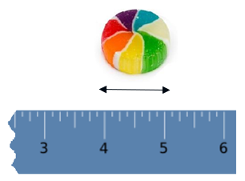

* The measurement of weight is determined by identifying and counting the number of units that represent the weight of an object.
* Benchmarks of common objects should be established for one pound and should be used when estimating weights. Practical experiences measuring the weight of familiar objects help to establish benchmarks. Students’ experiences should include the use of a variety of scales (e.g., bathroom scales, kitchen scales, balance scales, and spring scales), and instruction should include an explanation of how to use each type of scale.
* The measurement of liquid volume (capacity) is determined by identifying and counting the number of units that represent the volume of an object.
* Benchmarks of common objects should be established for one whole cup and should be used when estimating volume. Practical experiences measuring the volume (capacity) of familiar objects help to establish benchmarks. Student experiences should include the use of a variety of measuring cups, and instruction should include an explanation of how to use them.

###### Skills in Practice

While the five process goals are expected to be embedded in each standard, the Skills in Practice highlight the most prevalent process goals in relation to the content presented.

**Mathematical Reasoning:** Students should have opportunities to determine measurements of benchmark objects (e.g., items that are about one inch in length, items that weigh about one pound, containers that hold about one cup). This will help students compare objects to the benchmark as they reason and determine whether an object is shorter/longer than an inch, lighter/heavier than a pound, or holds less/more than one cup.

**Mathematical Connections:** Students may have difficulty recognizing tools that can be used to measure weight. For example, students may not be familiar with a kitchen scale or a balance (see images below) and may not understand that these can be used to measure weight.

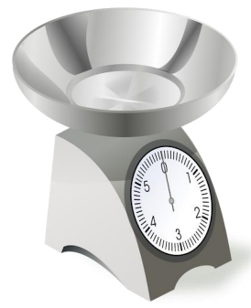 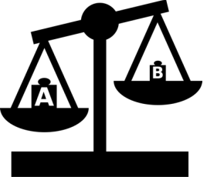

**Mathematical Representations:** Students may struggle to measure the length of an object to the nearest inch. They may begin measuring from the end of the ruler, rather than from the 0 mark. For example, in the image below, the end of the object is incorrectly lined up to the end of the ruler, rather than to the 0 mark on the ruler. This could result in students stating that the screwdriver is 4 inches long, rather than the correct response of 5 inches long. These students may benefit from constructing their own ruler from alternating colors of one-inch paper strips. Constructing a ruler in this way helps build conceptual understanding for measuring length.

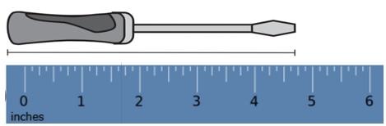

###### Concepts and Connections

Concepts

Analyzing and describing geometric objects in our world, the relationships and structures among them, or the space that they occupy can be used to classify, quantify, measure, or count one or more of their attributes.

Connections

* *Within the grade level/course*:
  + 2.NS.3 – The student will use mathematical reasoning and justification to solve contextual problems that involve partitioning models into equal-sized parts (halves, fourths, eighths, thirds, and sixths).
* *Vertical Progression*:
  + 1.MG.1 – The student will reason mathematically using nonstandard units to measure and compare objects by length, weight, and volume.
  + 3.MG.1 – The student will reason mathematically using standard units (U.S. Customary and metric) with appropriate tools to estimate and measure objects by length, weight/mass, and liquid volume to the nearest half or whole unit.

Across Content Areas [Theme – Modeling]

* *Science*: In second grade students are expected to use models to demonstrate simple phenomena and natural processes.
  + 2.4a – The student will analyze a model of the life cycle of an insect and describe the changes that occur within the life cycle.
  + 2.4a – The student will analyze a model of the life cycle of a mammal and describe the changes that occur with the life cycle.
  + 2.4ab – The student will develop models to describe the concept that organisms have unique and diverse life cycles but they all have in common birth, growth, reproduction, and death.
  + 2.5b – The student will analyze a model of a habitat and describe the living and nonliving components.
  + 2.7b – The student will model the effects of weathering and erosion on the land surface.
  + 2.7b – The student will design and construct a model of a structure that can withstand changes in land due to erosion or weathering.
  + 2.8c – The student will construct and interpret models as to how plans help reduce the impact of wind and water.
* *Computer Science*:
  + 2.DA.2 – The student will manipulate data, create representations, and evaluate data to solve a problem.
    - a) Create charts, graphs, and models using abstraction to represent data.
    - b) analyze data visualizations to draw conclusions.

###### Resources to Support Local Curriculum

* A list of approved textbooks and instructional materials is posted on the VDOE [website](https://www.doe.virginia.gov/teaching-learning-assessment/k-12-standards-instruction/mathematics/2024-mathematics-textbooks).

### 2.MG.2

##### The student will demonstrate an understanding of the concept of time to the nearest five minutes, using analog and digital clocks.

1. Students will demonstrate the following Knowledge and Skills:
2. Identify the number of minutes in an hour (60 minutes) and the number of hours in a day (24 hours).
3. Determine the unit of time (minutes, hours, days, or weeks) that is most appropriate when measuring a given activity or context and explain reasoning (e.g., Would you measure the time it takes to brush your teeth in minutes or hours?).
4. Show, tell, and write time to the nearest five minutes, using analog and digital clocks.
5. Match a written time (e.g., 1:35, 6:20, 9:05) to the time shown on an analog clock to the nearest five minutes.

###### Understanding the Standard

* Many experiences using clocks help students develop an understanding of the telling of time to the hour, half-hour, and nearest five minutes, including:
* the numbers in conjunction with the tick marks on a clock measure both hours and minutes, depending on the hand of the clock. The positions of the two hands on an analog clock are read to tell the time.
* a digital clock shows the time by displaying the time in numbers which are read as the hour and minutes.
* relating time on the hour and half-hour to daily routines and school schedules (e.g., bedtime, lunchtime, recess time).
* connecting the hour and half-hour to fraction concepts.
* The use of a demonstration clock with gears can be beneficial as it ensures that the positions of the hour hand and the minute hand are always precise and shows the relationship between the hour and minute hands.
* Time passes in equal increments (e.g., seconds, minutes, hours). There are 60 minutes in one hour and 24 hours in one day.
* Classroom experiences that help students determine the most appropriate unit of time for an activity or context will further their understanding of the passage of time. Examples might include:
  + Walking to the lunchroom from the classroom can be measured in minutes.
  + It would be best to measure the time it takes to complete one day of school in hours.
  + It takes only minutes for me to brush my teeth.
* The concepts of a.m. and p.m. are developed through relevant, contextual events (e.g., students eat breakfast in the a.m. hours or go to bed in the p.m. hours). This will help with the understanding of elapsed time in future grades.

###### Skills in Practice

While the five process goals are expected to be embedded in each standard, the Skills in Practice highlight the most prevalent process goals in relation to the content presented.

**Mathematical Representations:** Students may have difficulty determining the time on an analog clock. For example, given the analog clock below, students could make the following errors –

* confusing the hour hand and the minute hand, resulting in reading the time as 10:25. For students who confuse the hour and minute hand, opportunities to practice reading clocks with only the hour hand may be beneficial.
* reading the minute hand incorrectly, and not counting by 5s, resulting in reading the time as 4:10. These students would benefit from additional opportunities to develop their skills in counting by fives and in making sense of each five-minute interval on the clock.
* incorrectly reading the time as it approaches the next hour, resulting in reading the time as 5:50. These students have difficulty understanding how the hour hand moves in relation to the movement of the minute hand. The use of a “geared clock” would benefit these students as it illustrates how the position of the hour hand changes as the minute hand progresses around the clock.

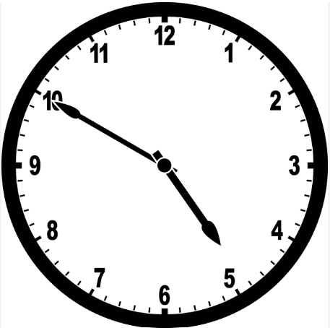

###### Concepts and Connections

Concepts

Analyzing and describing geometric objects in our world, the relationships and structures among them, or the space that they occupy can be used to classify, quantify, measure, or count one or more of their attributes.

Connections

* *Within the grade level/course*:
  + 2.NS.1b – The student will represent forward counting patterns created when counting by groups of 5s, 10s, and 25s starting at various multiples up to at least 200 using a variety of tools (e.g., objects, number lines, hundreds charts).
  + 2.NS.3e – The student will, given a context, represent, name, and write fractional parts of a whole for halves, fourths, eighths, thirds, and sixths…
* *Vertical Progression*:
  + 1.MG.3 – The student will demonstrate an understanding of the concept of passage of time (to the nearest hour and half-hour) and the calendar.
  + 3.MG.3 – The student will demonstrate an understanding of the concept of time to the nearest minute and solve single-step contextual problems involving elapsed time in one-hour increments within a 12-hour period.

Across Content Areas

Reference 2.MG.1.

###### Resources to Support Local Curriculum

* A list of approved textbooks and instructional materials is posted on the VDOE [website](https://www.doe.virginia.gov/teaching-learning-assessment/k-12-standards-instruction/mathematics/2024-mathematics-textbooks).

### 2.MG.3

##### The student will identify, describe, and create plane figures (including circles, triangles, squares, and rectangles) that have at least one line of symmetry and explain its relationship with congruency.

1. Students will demonstrate the following Knowledge and Skills:
2. Explore a figure using a variety of tools (e.g., paper folding, geoboards, drawings) to show and justify a line of symmetry, if one exists.
3. Create figures with at least one line of symmetry using various concrete and pictorial representations.
4. Describe the two resulting figures formed by a line of symmetry as being congruent (having the same shape and size).

###### Understanding the Standard

* A line of symmetry divides a figure into two congruent parts, each of which is the mirror image of the other. (The figures could be folded on the line of symmetry and both parts would match exactly. The two parts are congruent – the same size and shape.) Lines of symmetry can be horizontal, vertical, or diagonal. Two examples are shown below:

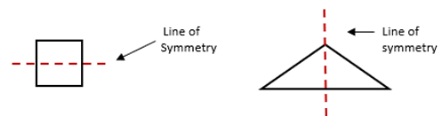

* Children learn about symmetry through hands-on experiences with geometric figures and the creation of geometric pictures and patterns.
* Guided explorations of the study of symmetry using mirrors, paper folding, geoboards, and pattern blocks will enhance students’ understanding of the attributes of symmetrical figures.
* Congruent figures have exactly the same size and shape. Figures that are not congruent do not have exactly the same size and shape. Congruent figures remain congruent even if they are in different spatial orientations.
* Symmetry is justified by describing the resulting shapes of a divided figure as congruent.
* While investigating symmetry, children move figures, such as pattern blocks, intuitively, thereby exploring transformations of those figures. A transformation is the movement of a figure — either a translation, rotation, or reflection. A translation is the result of sliding a figure in any direction; a rotation is the result of turning a figure around a point or a vertex; and a reflection is the result of flipping a figure over a line. Children at this level do not need to know the terms related to transformations of figures.

###### Skills in Practice

While the five process goals are expected to be embedded in each standard, the Skills in Practice highlight the most prevalent process goals in relation to the content presented.

**Mathematical Reasoning:** When given a rectangle, like the one shown below, students may draw a diagonal line to show symmetry. While a diagonal line subdivides a rectangle into two equal parts that are congruent, the parts are not mirror images (reflections) of each other; therefore, the diagonal is not a line of symmetry.

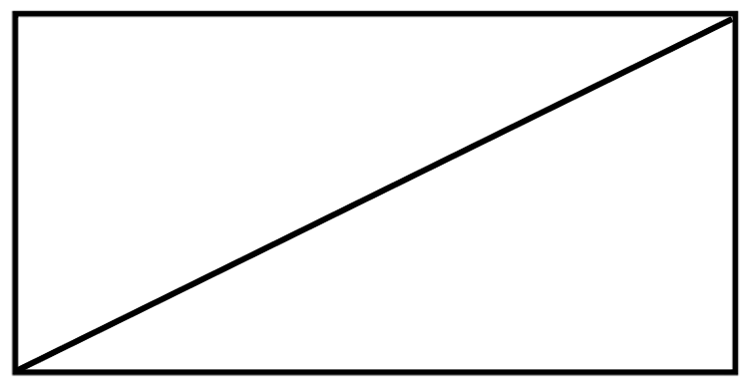

**Mathematical Representations:** Students may have difficulty identifying and drawing lines of symmetry in irregular figures, such as those shown below. Students who struggle to identify or draw lines of symmetry would benefit from opportunities to use lines to divide a variety of figures into two parts and discuss whether the line results in two parts that are mirror images (reflections).

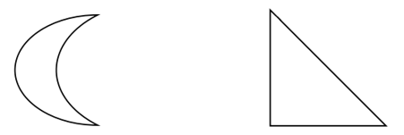

###### Concepts and Connections

Concepts

Analyzing and describing geometric objects in our world, the relationships and structures among them, or the space that they occupy can be used to classify, quantify, measure, or count one or more of their attributes.

Connections

* *Within the grade level/course*:
  + 2.MG.4 – The student will describe, name, compare, and contrast plane and solid figures (circles/spheres, squares/cubes, and rectangles/rectangular prisms).
  + 2.PFA.1 – The student will describe, extend, create, and transfer repeating and increasing patterns (limited to addition of whole numbers) using various representations.
* *Vertical Progression*:
  + 1.MG.2 – The student will describe, sort, draw, and name plane figures (circles, triangles, squares, and rectangles), and compose larger plane figures by combining simple plane figures.
  + 3.MG.4 – The student will identify, describe, classify, compare, combine, and subdivide polygons.

Across Content Areas

Reference 2.MG.1.

###### Resources to Support Local Curriculum

* A list of approved textbooks and instructional materials is posted on the VDOE [website](https://www.doe.virginia.gov/teaching-learning-assessment/k-12-standards-instruction/mathematics/2024-mathematics-textbooks).

### 2.MG.4

##### The student will describe, name, compare, and contrast plane and solid figures (circles/spheres, squares/cubes, and rectangles/rectangular prisms).

1. Students will demonstrate the following Knowledge and Skills:
2. Trace faces of solid figures (cubes and rectangular prisms) to create the set of plane figures related to the solid figure.
3. Compare and contrast models and nets (cutouts) of cubes and rectangular prisms (e.g., number and shapes of faces, edges, vertices).
4. Given a concrete or pictorial model, name and describe the solid figure (sphere, cube, and rectangular prism) by its characteristics (e.g., number of edges, number of vertices, shapes of faces).
5. Compare and contrast plane and solid figures (circles/spheres, squares/cubes, and rectangles/rectangular prisms) according to their characteristics (e.g., number and shapes of their faces, edges, vertices).

###### Understanding the Standard

* An important part of the geometry strand in kindergarten through Grade 2 is the naming and describing of figures. Children move from their own vocabulary and begin to incorporate conventional terminology as the teacher uses geometric terms.
  + A plane figure is any closed, two-dimensional shape.
  + A vertex is a point at which two or more lines, line segments, or rays meet to form an angle. In solid figures, a vertex is the point at which three or more edges meet.

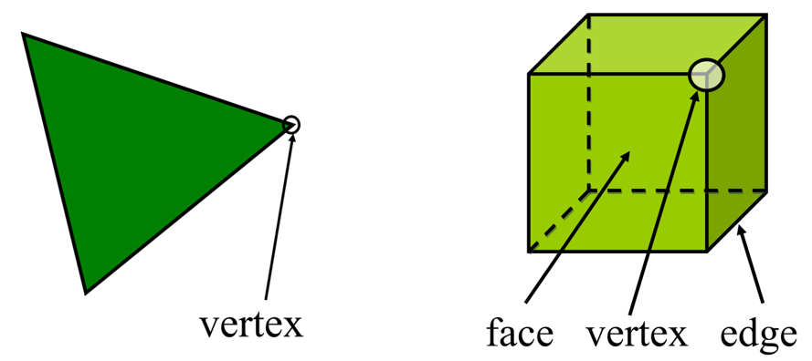

* + A line is a collection of points extending indefinitely in both directions. It has no endpoints.
  + A line segment is part of a line. It has two endpoints and includes all the points between and including those endpoints.
  + A ray is part of a line. It has one endpoint and extends indefinitely in one direction.
  + An angle is formed by two rays that share a common endpoint called the vertex. Angles are found wherever lines or line segments intersect.
  + A solid figure is a three-dimensional figure that has length, width, and height.
  + A circle is a set of points in a plane (e.g., two-dimensional) that are the same distance from a point called the center. A circle has no edges or vertices.
  + A sphere is a solid figure with all its points in space (e.g., three-dimensional) that are the same distance from its center. A sphere has no edges or vertices.
  + A rectangle is a quadrilateral with four right angles.
  + A square is a special type of rectangle with four congruent (equal length) sides and four right angles.
  + A right angle measures exactly 90 degrees.
  + A rectangular prism is a solid figure in which all six faces are rectangles. A rectangular prism has eight vertices and 12 edges.
  + A cube is a solid figure with six congruent, square faces. All edges are the same length. A cube has eight vertices and 12 edges. It is a special type of rectangular prism.
  + An edge is the line segment where two faces of a solid figure intersect.
  + A face is any flat side of a solid figure (e.g., a square is a face of a cube).
* Examples of plane (two-dimensional) and solid (three-dimensional) figures are shown in the table below.

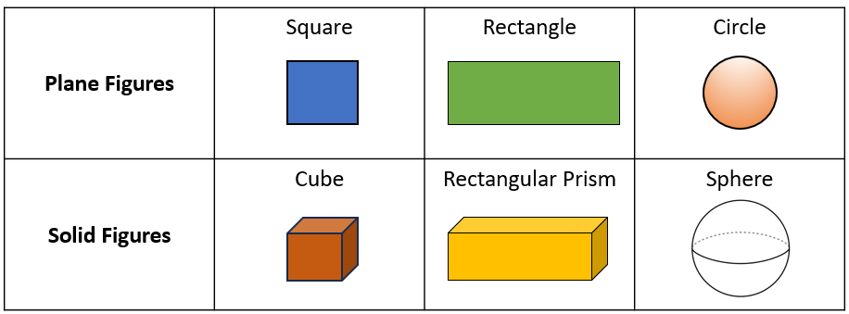

* Hands-on, contextual experiences with plane and solid figures develop an understanding of the characteristics of each when making comparisons.
* Tracing the faces of cubes and rectangular prisms, decomposing cubes and rectangular prisms along their edges, and using nets to compose cubes and rectangular prisms help students understand the set of plane figures related to the solid figure.
* The net of a solid figure is what the figure would look like if it was unfolded. The image below shows an example of the net of a rectangular prism. Nets can be used to fold and compose three-dimensional shapes to develop an understanding of the relationship between the net and the solid figure they represent.

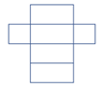

Net of a rectangular prism

###### Skills in Practice

While the five process goals are expected to be embedded in each standard, the Skills in Practice highlight the most prevalent process goals in relation to the content presented.

**Mathematical Communication:** There is a lot of vocabulary associated with this unit of instruction. Students may confuse or misuse the terms, including *vertices, edges,* and *faces*. These students will need additional opportunities to explore and name shapes and describe the characteristics of shapes. Word banks or vocabulary cards may be helpful as students become more comfortable with these terms. It is important for teachers to use these terms during instruction so that students become familiar with accurate and appropriate terminology. Activities such as sorting shapes using descriptors and characteristics or the use of graphic organizers that require students to group objects based on their characteristics will provide opportunities for students to use geometry terms.

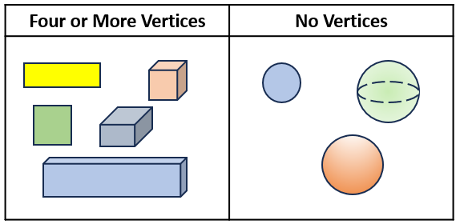

**Mathematical Connections:** Students may not understand the difference between two-dimensional and three-dimensional figures. For example, they may incorrectly identify a cube by stating that it is a square. Opportunities to use physical models of three-dimensional shapes will help students see the differences between two-dimensional and three-dimensional figures.

###### Concepts and Connections

Concepts

Analyzing and describing geometric objects in our world, the relationships and structures among them, or the space that they occupy can be used to classify, quantify, measure, or count one or more of their attributes.

Connections

* *Within the grade level/course*:
  + 2.MG.3 – The student will identify, describe, and create plane figures (including circles, triangles, squares, and rectangles) that have at least one line of symmetry and explain its relationship with congruency.
  + 2.PFA.1 – The student will describe, extend, create, and transfer repeating and increasing patterns (limited to addition of whole numbers) using various representations.
* *Vertical Progression*:
  + 1.MG.2 – The student will describe, sort, draw, and name plane figures (circles, triangles, squares, and rectangles), and compose larger plane figures by combining simple plane figures.
  + 3.MG.4 – The student will identify, describe, classify, compare, combine, and subdivide polygons.

Across Content Areas

Reference 2.MG.1.

###### Resources to Support Local Curriculum

* A list of approved textbooks and instructional materials is posted on the VDOE [website](https://www.doe.virginia.gov/teaching-learning-assessment/k-12-standards-instruction/mathematics/2024-mathematics-textbooks).

## Probability and Statistics

In K-12 mathematics, probability and statistics introduce students to the concepts of uncertainty and data analysis. Probability involves understanding the likelihood of events occurring, often using concepts such as experiments, outcomes, and the use of fractions and percentages. The formal study or probability begins in Grade 4. Statistics focuses on collecting, organizing, and interpreting data and includes a basic understanding of graphs and charts. Probability and statistics help students analyze and make sense of real-world data and are fundamental for developing critical thinking skills and making informed decisions using data.

In Grade 2, students deepen their understanding that the world can be investigated through posing questions and collecting, representing, analyzing, and interpreting data to describe and predict events and real-world phenomena. At this grade level, students will apply the data cycle (pose questions; collect or acquire data; organize and represent data; and analyze data and communicate results) with a focus on pictographs and bar graphs.

### 2.PS.1

##### The student will apply the data cycle (pose questions; collect or acquire data; organize and represent data; and analyze data and communicate results) with a focus on pictographs and bar graphs.

1. Students will demonstrate the following Knowledge and Skills:
2. Pose questions, given a predetermined context, that require the collection of data (limited to 25 or fewer data points for no more than six categories).
3. Determine the data needed to answer a posed question and collect the data using various methods (e.g., voting; creating lists, tables, or charts; tallying).
4. Organize and represent a data set using a pictograph where each symbol represents up to 2 data points. Determine and use a key to assist in the analysis of the data.
5. Organize and represent a data set using a bar graph with a title and labeled axes (limited to 25 or fewer data points for up to six categories, and limit increments of scale to multiples of 1 or 2).
6. Analyze data represented in pictographs and bar graphs and communicate results:
   1. ask and answer questions about the data represented in pictographs and bar graphs (e.g., total number of data points represented, how many in each category, how many more or less are in one category than another). Pictograph keys will be limited to symbols representing 1, 2, 5, or 10 pieces of data and bar graphs will be limited to scales with increments in multiples of 1, 2, 5, or 10; and
   2. draw conclusions about the data and make predictions based on the data.

###### Understanding the Standard

* Students should explore the entire data cycle with a question and set of data that has been collected or acquired. Student reflection should occur throughout the data cycle. The data cycle includes the following steps: formulating questions to be explored with data, collecting or acquiring data, organizing and representing data, and analyzing and communicating results.

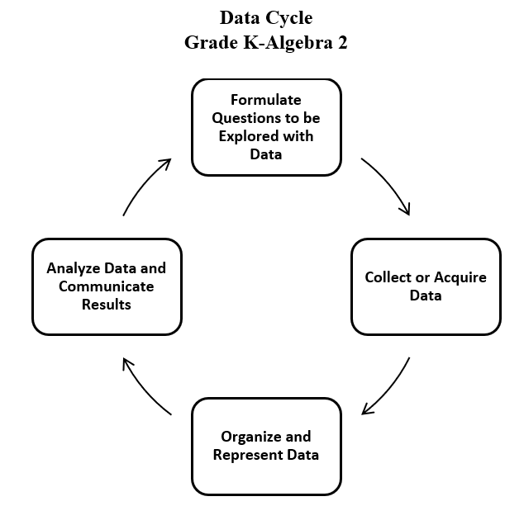

* Data are pieces of information collected about people or things. The primary purpose of collecting data is to answer questions. The primary purpose of interpreting data is to inform decisions (e.g., which type of clothing to pack for a vacation based on a weather graph or which type of lunch to serve based upon class favorites).
* The teacher can provide data sets to students in addition to students engaging in their own data collection. Data may be acquired from resources that are already created (e.g., list of student birthdays, transportation lists, weather data, lunchroom data, media center data, data from a previously conducted experiment).
* After generating questions, students decide what information is needed and how it can be collected.
* The collection of the data often leads to new questions to be investigated.
* The purpose of a graph is to represent data gathered to answer a question. In Grade 2, students are expected to collect and organize data in bar graphs and pictographs.
* A bar graph is used to show comparisons between categories and to organize the data for larger data sets. The scale of a bar graph allows for easy representation of all data frequencies. Bar graphs may be created with horizontal bars or vertical bars. Examples of a vertical bar graph and horizontal bar graph are shown below.

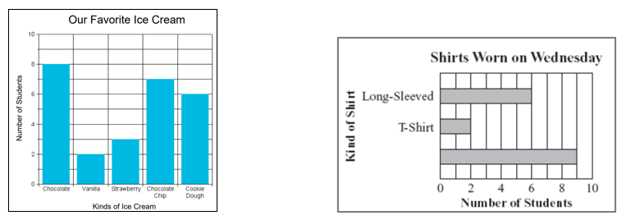 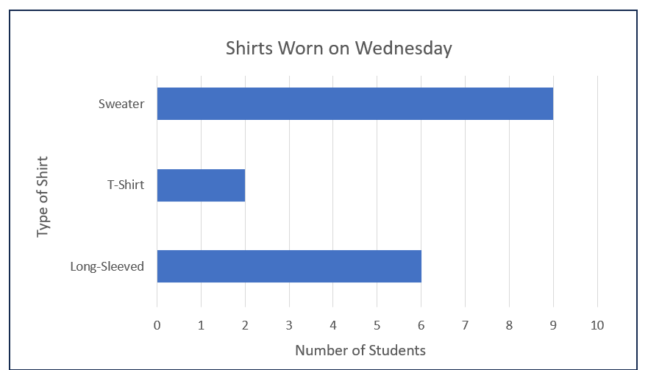

* A pictograph is used to show frequencies and show comparisons between categories. Pictographs can be challenging to read because a symbol can represent more than one data point.
* Pictographs can be horizontal or vertical. Examples of a horizontal pictograph and vertical pictograph are shown below.

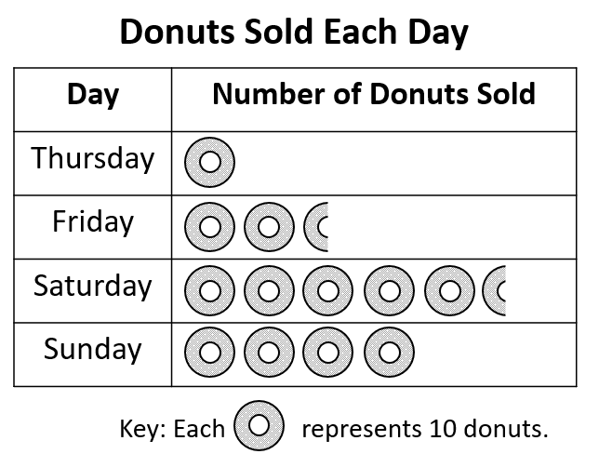 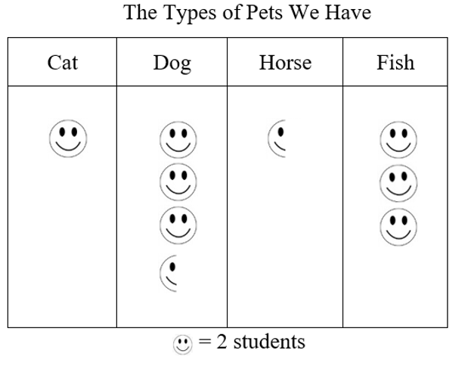

* A key should be provided when the symbol represents more than one piece of data to assist in the analysis of the displayed data. At this level, each symbol should represent 1, 2, 5, or 10 pieces of data (e.g.,  represents two people in the pictograph above).
* Students’ prior knowledge and work with skip counting helps them to identify the number of pictures or symbols to be used in a pictograph.
* Definitions for the terms picture graph and pictographs vary. Pictographs are most often defined as a pictorial representation of numerical data. The focus of instruction should be placed on reading and using the key in analyzing the graph. There is no need for students to distinguish between a picture graph and a pictograph.
* Bar graphs are used to compare frequencies of different categories (categorical data). Using grid paper may ensure more accurate graphs.
* A bar graph uses horizontal or vertical parallel bars to represent counts for several categories. One bar is used for each category, with the length of the bar representing the count for that category. There is space before, between, and after each of the bars.
* The axis displaying the scale that represents the count for the categories should begin at zero and extend one increment above the greatest recorded piece of data. In Grade 2, data are recorded in increments of whole numbers limited to multiples of 1, 2, 5, or 10.
* At this level, the number of categories on a bar graph should be limited to six. A key should be included where appropriate.
* Each axis should be labeled, and the graph should be given a title. At this level students are not expected to use the word axis.
* Statements that represent an analysis and interpretation of the data in the graph should be discussed with students and written (e.g., similarities and differences, least and greatest, the categories, total number of responses, how many more or less are in one category than another).
* The data cycle can be used to make connections between mathematics and other disciplines including English, social studies, or science.
  + Sample Connections to English Standards of Learning
    - Who is your favorite author?
    - What is your favorite story that was read in class?
    - What is your favorite type of book to read?
  + Sample Connections to History and Social Science Standards of Learning
    - How do you demonstrate good citizenship?
    - What is your favorite holiday?
    - Who is your favorite famous American studied in social studies class?
    - Taking part of the voting process when making classroom decisions
  + Sample Connections to Science Standards of Learning
    - Graph daily weather conditions
    - Gather data on whether objects are magnetic or not
    - Gather data on whether objects are solids, liquids, or gases
* Students would benefit from exploring previously taught graphical representations when justifying how to best represent data clearly and accurately. Comparing different types of representations (charts and graphs) provides an opportunity to learn how different graphs can show different things about the same data. Discussions around what information different graphs representing the same data provides is beneficial for determining which graphical representation best represents the data.

###### Skills in Practice

While the five process goals are expected to be embedded in each standard, the Skills in Practice highlight the most prevalent process goals in relation to the content presented.

**Mathematical Communication:** As Grade 2 students engage in the data cycle, they will likely struggle to pose questions that require the collection of data. Teacher support will be necessary to help students distinguish between questions that require data to answer and questions that do not require data to answer. For example, “Do we have art class today?” is a question that does not require data to answer; the answer is simply yes or no. Questions that require the collection of data could include anything that involves surveying other students, measuring, or counting and quantifying amounts (see examples below).

* Question that requires surveying: What is your favorite activity to do during recess?
* Question that requires measuring: How much rain did we get each day this month?
* Question that requires counting and quantifying: How was the weather been this month (sunny, rainy, cloudy)?

**Mathematical Reasoning:** Students may have difficulty with the concept of zero when representing data in a pictograph or bar graph. For example, if a category has zero data points, students may still try to represent that category using a picture or a bar. Additional opportunities to analyze and create pictographs and bar graphs where one or more categories contains zero data points would be beneficial. Classroom discussions that focus on what it means when there are no data points in a category will be helpful for students as they make sense of and represent data accurately.

**Mathematical Representations:** Grade 2 is students’ first formal exposure to pictographs where the key may represent more than one object and bar graphs where the scale may increase by more than one number each time. Some students may have difficulty analyzing and interpreting such graphs. Some common errors include:

* counting each object or bar by one instead of using the key or scale. These students would benefit from experiences where they collect their own data and then translate it to a pictograph or bar graph using a key or scale beyond one.
* incorrectly counting by twos, fives, or tens to determine the amount represented in each category. These students would benefit from additional experiences with skip counting.
* incorrectly representing a category that has an odd number of objects using a key or scale that counts by twos. These students would benefit from additional experiences collecting data using a table or chart and then creating a pictograph where each symbol represents more than one data point.

###### Concepts and Connections

Concepts

Investigating the world through posing questions, collecting data, organizing and representing data, and analyzing data and communicating results can be used to describe and predict events and real-world phenomena.

Connections

* *Within the grade level/course*:
  + 2.CE.1 – The student will recall with automaticity addition and subtraction facts within 20 and estimate, represent, solve, and justify solutions to single-step and multistep problems, including those in context, using addition and subtraction with whole numbers where addends or minuends do not exceed 100.
* *Vertical Progression*:
  + 1.PS.1 – The student will apply the data cycle (pose questions; collect or acquire data; organize and represent data; and analyze data and communicate results) with a focus on object graphs, picture graphs, and tables.
  + 3.PS.1 – The student will apply the data cycle (formulate questions; collect or acquire data; organize and represent data; and analyze data and communicate results) with a focus on pictographs and bar graphs.

Across Content Areas [Theme – Using Data]

* *Science:* 
  + 2.2b – The student will investigate relationships of gravitational or magnetic interactions between two objects that are not in contact with each other.
  + 2.6b – The student will observe, describe, and record daily weather conditions using weather instruments; graph and analyze data to identify patterns; and predict weather based upon identified patterns.
* *Computer Science*:
  + 2.DA.1 – The student will analyze data to make decisions with or without a computing device.
    - a) Collect and record numeric and non-numeric data and describe possible patterns.
    - b) Create questions that can and cannot be answered by the data.
    - c) Analyze data to draw conclusions and make decisions.
  + 2.DA.2 – The student will manipulate data, create representations, and evaluate data to solve a problem.
    - a) Create charts, graphs, and models using abstraction to represent data.
    - b) Analyze data visualizations to draw conclusions.
    - c) Propose and evaluate a solution to a problem or question based on data and/or data visualization.

Across Content Areas [Theme – Graphing]

* *Science*: Depending on the data collected in an investigation, they may use graphs to visualize the data.
  + 2.6b – The student will observe, describe, and record daily weather conditions using weather instruments; graph and analyze data to identify patterns; predict weather based upon identified patterns.
* *Computer Science*:
  + 2.DA.2 – The student will manipulate data, create representations, and evaluate data to solve a problem.
    - a) Create charts, graphs, and models using abstraction to represent data.
    - b) Analyze data visualizations to draw conclusions.

###### Resources to Support Local Curriculum

* A list of approved textbooks and instructional materials is posted on the VDOE [website](https://www.doe.virginia.gov/teaching-learning-assessment/k-12-standards-instruction/mathematics/2024-mathematics-textbooks).
* Data Cycle Teacher Resource ([PPT](https://www.doe.virginia.gov/home/showdocument?id=52071&t=638411641444770000) | [PDF](https://www.doe.virginia.gov/home/showdocument?id=52069&t=638411641438670000))
* All About the Data Exemplar Mathematics Instructional Plan ([Word](https://www.doe.virginia.gov/home/showpublisheddocument/51753/638398745301200000) | [PDF](https://www.doe.virginia.gov/home/showpublisheddocument/51755/638398745307770000))
* Accompanying Slow Reveal Graph ([PPT](https://www.doe.virginia.gov/home/showpublisheddocument/51751/638398745295900000) | [PDF](https://www.doe.virginia.gov/home/showpublisheddocument/51749/638398745290270000))

## Patterns, Functions, and Algebra

In K-12 mathematics, the patterns, functions, and algebra strand focuses on the recognition, description, and analysis of patterns, functions, and algebraic concepts. Students develop an understanding of mathematical relationships and represent these using symbols, tables, graphs, and rules. In later grades, students use models as they solve equations and inequalities and develop an understanding of functions. This strand is designed to develop students’ algebraic thinking and problem-solving skills, laying the foundation for more advanced mathematical concepts.

In Grade 2, students understand that relationships can be described, and generalizations can be made using patterns and relations. At this grade level, students will identify, describe, extend, create, and transfer repeating and increasing patterns (limited to addition of whole numbers) in various representations.

### 2.PFA.1

##### The student will describe, extend, create, and transfer repeating and increasing patterns (limited to addition of whole numbers) using various representations.

1. Students will demonstrate the following Knowledge and Skills:
2. Identify and describe repeating and increasing patterns.
3. Analyze a repeating or increasing pattern and generalize the change to extend the pattern using objects, pictures, and numbers.
4. Create a repeating or increasing pattern using various representations (e.g., objects, pictures, numbers).
5. Transfer a given repeating or increasing pattern from one form to another (e.g., objects, pictures, numbers) and explain the connection between the two patterns.

###### Understanding the Standard

* Patterning is a fundamental cornerstone of mathematics, particularly algebra. The process of generalization leads to the foundation of algebraic reasoning. A generalization allows students to recognize a new situation in which it can be applied and adapted appropriately.
* Opportunities to create, identify, describe, extend, and transfer patterns are essential to the primary school experience and lay the foundation for understanding place value and thinking algebraically.
* In a repeating pattern, the part of the pattern that repeats is called the core. In the pattern below, the core is smiley face, heart, heart, lightning bolt.

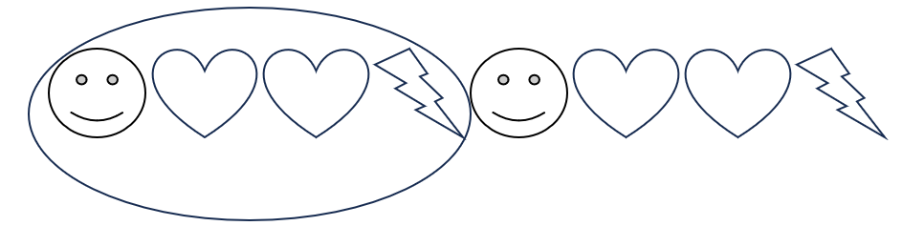

* Growing patterns involve a progression from term to term, which makes them more challenging for students than repeating patterns. Growing patterns can increase or decrease. Students in Grade 1 worked with repeating patterns and were introduced to increasing patterns. At this level, students will deepen their understanding of increasing patterns. Students must determine what comes next, and begin the process of generalization, which leads to the foundation of algebraic reasoning. Students need experiences identifying what changes and what stays the same in a pattern. Increasing patterns may be represented in various ways, including with numbers, dot patterns, pictures, number lines, hundreds charts, etc.
* In an increasing pattern, students must determine the difference, called the common difference, between each succeeding number to determine what is added to each previous number to obtain the next number. Students do not need to use the term common difference at this level.
* In Grade 2, patterns will be limited to increasing values.
* Sample numeric patterns include:
  + 6, 9, 12, 15, 18, … (increasing pattern);
  + 2, 4, 6, 8, 10, … (increasing pattern); and
  + 1, 3, 5, 1, 3, 5, 1, 3, 5… (repeating pattern).
* A sample contextual increasing pattern is shown below:

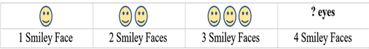**How Many Eyes?**

* Additional contextual examples could include the number of wheels on bikes, the number of legs on chairs, etc.
* In patterns using objects or figures, students must often recognize transformations of a figure, particularly rotations or reflections. Rotation is the result of turning a figure, and reflection is the result of flipping a figure over a line. Children at this level do not need to know the terms related to transformations of figures.
* Examples of patterns using objects or figures include:

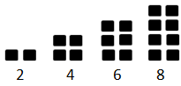Repeating pattern with right trianglesRepeating pattern: right arrow, circle, up arrow, down arrow, right arrow, circle, up arrow, down arrow

* Transferring a pattern is creating the pattern in a different form or representation.
* Examples of pattern transfers include:
  + 10, 20, 30, 40… has the same structure as 14, 24, 34, 44… because both patterns increase by 10;
  + Repeating pattern: Trapezoid, circle, triangle, circle, trapezoid, circle, triangle, circle has the same structure as because the core (first 4 shapes) repeats; and
  + 1, 3, 5, 1, 3, 5, 1, 3, 5 has the same structure as ABCABC.

###### Skills in Practice

While the five process goals are expected to be embedded in each standard, the Skills in Practice highlight the most prevalent process goals in relation to the content presented.

**Mathematical Problem Solving:** Students may have difficulty extending a pattern that grows (increases) as demonstrated in the example below. For example, students may write 4, or 4, 5, or 4, 5, 6. Other students may fill in all of the blanks with 4’s. These errors may indicate that students recognize that this pattern is increasing, but do not understand *how* the pattern is increasing and therefore, are unable to accurately extend the pattern. Classroom discussions about examples of increasing patterns and additional practice extending them will be helpful. Additional opportunities to compare repeating and increasing patterns would also support students’ understanding about the similarities and differences between repeating and increasing patterns.

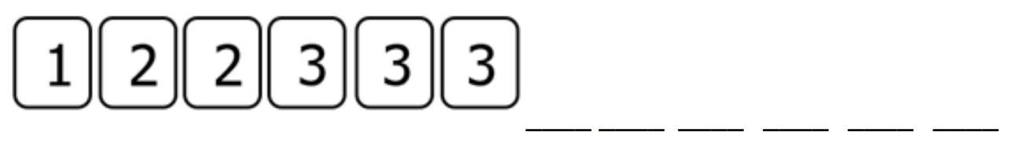

**Mathematical Reasoning:** Students may struggle to complete a repeating pattern that contains more than two different elements or contains elements of varying numbers. For example, given the pattern below, students may incorrectly say that the triangle comes next. This may indicate that students are unable to identify the core of the pattern, or they may not have paid close attention to the two stars in the core. Students may benefit from being instructed to circle or underline the core of the pattern. Additionally, students may benefit from coloring the pattern (i.e., all stars one color, all triangles another color, all squares a third color), which will allow them to see the color pattern and help them to visualize what comes next.



**Mathematical Representations:** Students may have difficulty transferring patterns from one representation to another. Students who transfer patterns need additional opportunities to collaborate with classmates to describe and analyze patterns and then represent those same patterns in different forms. Transferring patterns becomes easier for students once they can identify the core and extend patterns.

###### Concepts and Connections

Concepts

Relationships are described and generalizations are made using patterns, relations, and functions.

Connections

* *Within the grade level/course*:
  + 2.CE.1 – The student will recall with automaticity addition and subtraction facts within 20 and estimate, represent, solve, and justify solutions to single-step and multistep problems, including those in context, using addition and subtraction with whole numbers where addends or minuends do not exceed 100.
  + 2.MG.4 – The student will describe, name, compare, and contrast plane and solid figures (circles/spheres, squares/cubes, rectangles/rectangular prisms).
* *Vertical Progression*:
  + 1.PFA.1 – The student will identify, describe, extend, create, and transfer repeating patterns and increasing patterns using various representations.
  + 3.PFA.1 – The student will identify, describe, extend, and create increasing and decreasing patterns (limited to addition and subtraction of whole numbers), including those in contexts, using various representations.

Across Content Areas [Theme – Numbers, Number Sense, and Patterns]

* *Science:* 
  + 2.4 – The student will investigate and understand that plants and animals undergo a series of orderly changes as they grow and develop.
  + 2.6b – The student will observe, describe, and record daily weather conditions using weather instruments; graph and analyze data to identify patterns; and predict weather based upon identified patterns.
  + 2.6c – The student will observe and describe seasonal weather patterns and local variations.
  + 2.7 – The student will investigate and understand that weather patterns and seasonable changes affect plants, animals, and their surroundings.
* *Computer Science*:
  + 2.AP.1 – The student will apply computational thinking to identify patterns, and design algorithms to compare and contrast objects based on attributes.
    - a) Compare and contrast multiple ways to sort a set of objects.
    - b) Create a table of features to organize objects.
    - c) Design an algorithm to sort objects into categories based on multiple attributes.
  + 2.AP.2 – The student will identify a section of repeated actions within an algorithm and replace it with a loop.

###### Resources to Support Local Curriculum

* A list of approved textbooks and instructional materials is posted on the VDOE [website](https://www.doe.virginia.gov/teaching-learning-assessment/k-12-standards-instruction/mathematics/2024-mathematics-textbooks).